Tab 1
Treasure Row

Donovan Griffin, Jonah Goodwine, Cameron Ridgley, Chase Jones, Ricki Davis, Chi Martin, Noah Higgs



Design Specifications

Table of Contents

1.0 Introduction (Chi Martin) 5
1.1 Goals and Objectives 5
1.2 Statement of Scope 6
1.3 Software Context 7
1.4 Major Constraints 7
2.0 Data Design (Chi Martin) 8
2.1 Internal Software Data Structure (Chi Martin) 8
2.2 Global Data Structure (Chi Martin) 9
2.3 Temporary Data Structure 9
2.4 Database Description (Chi Martin) 9
2.4.1 Table Definitions 10
2.4.2 Entity Relationships 14
2.4.3 Database Constraints and Indexes 15
2.4.4 Schema Initialization and Limitations 15
3.0 Architectural and Component-Level Design (Chi Martin) 15
3.1 Program Structure (Chi Martin) 16
3.1.1 Architecture Diagram (Chi Martin) 17
3.1.2 Alternatives (Chi Martin) 19
3.2 Description for Web Interface (Chi Martin) 19
3.2.1 Processing Narrative (PSPEC) for Web Interface (Chi Martin) 19
3.2.2 Web Interface Description (Chi Martin) 19
3.2.3 Sub-Component: S3 Image Upload 20
3.2.3.1 Interface Description 21
3.2.3.2 Algorithmic Model (e.g., PDL) 21
3.2.3.3 Restrictions/Limitations 21
3.2.3.4 Local Data Structures 21
3.2.3.5 Performance Issues 21
3.2.3.6 Design Constraints 21
3.3 Description for Flask Application Server (Chi Martin) 22
3.3.1 Processing Narrative (PSPEC) for Flask Application Server 22
3.3.2 Flask Application Server Interface Description 22
3.3.3 Sub-Component Processing Detail 23
3.3.3.1 Interface Description 23
3.3.3.2 Algorithmic Model (e.g., PDL) 24
3.3.3.3 Restrictions/Limitations 24
3.3.3.4 Local Data Structures 24
3.3.3.5 Performance Issues 25
3.3.3.6 Design Constraints 25
3.3.3.7 Checkout and Treasure Tokens Processing 26
3.4 Description for Controller Layer (Chi Martin) 26
3.4.1 Processing Narrative (PSPEC) for Controller Layer 27
3.4.2 Controller Layer Interface Description 27
3.4.3 Sub-Component Processing Detail 28
3.4.3.1 Create Listing 28
3.4.3.2 Algorithmic Model (e.g., PDL) 29
3.4.3.3 Restrictions/Limitations 30
3.4.3.4 Local Data Structures 30
3.4.3.5 Performance Issues 30
3.4.3.6 Design Constraints 30
3.5 Description for Service Layer (Chi Martin) 31
3.5.1 Processing Narrative (PSPEC) for Service Layer 31
3.5.2 Service Layer Interface Description 31
3.5.3 Sub-Component n.m Processing Detail 32
3.5.3.1 Interface Description 32
3.5.3.2 Algorithmic Model (e.g., PDL) 32
3.5.3.3 Restrictions/Limitations 33
3.5.3.4 Local Data Structures 33
3.5.3.5 Performance Issues 33
3.5.3.6 Design Constraints 34
3.6 Description for Data Model and Database Access Layer (Chi Martin) 34
3.6.1 Processing Narrative (PSPEC) for Data Model and Database Access Layer 34
3.6.2 Data Model and Database Access Layer Interface Description 34
3.6.3 Sub-Component n.m Processing Detail 34
3.6.3.1 Interface Description 35
3.6.3.2 Algorithmic Model (e.g., PDL) 35
3.6.3.3 Restrictions/Limitations 36
3.6.3.4 Local Data Structures 36
3.6.3.5 Performance Issues 37
3.6.3.6 Design Constraints 37
3.6.3.7 Token Model and Database Access 38
3.7 Software Interface Description (Chi Martin) 38
3.7.1 External Machine Interfaces (Chi Martin) 38
3.7.2 External System Interfaces (Chi Martin) 39
3.7.3 Human Interface (Chi Martin) 39
4.0 User Interface Design 39
4.1 Description of the User Interface (Chi Martin) 40
4.1.1 Screen Images (Chi Martin) 40
4.1.2 Objects and Actions (Chi Martin) 44
4.2 Interface Design Rules (Chi Martin) 47
4.3 Components Available (Chi Martin) 47
4.4 UIDS Description (Chi Martin) 47
5.0 Restrictions, Limitations, and Constraints (Chi Martin) 48
6.0 Testing Issues 49
6.1 Classes of Tests (Chi Martin) 49
6.2 Expected Software Response (Chi Martin) 50
6.3 Performance Bounds (Chi Martin) 50
6.4 Identification of Critical Components (Chi Martin) 51
7.0 Revision Logs (Chi Martin) 52

1.0 Introduction (Chi Martin)
Treasure Row is a web-based campus marketplace for Hampton University students, developed from an inherited campus marketplace codebase. The system enables authenticated users to create storefronts, publish clothing listings, browse and search marketplace content, maintain wishlists and shopping carts, place orders, coordinate in-person exchanges, and submit return requests. Administrators can manage marketplace resources and perform authorized administrative operations.

The application uses a Python Flask backend, server-rendered HTML templates, JavaScript and CSS, and a PostgreSQL database. The backend follows a layered architecture comprising controllers, services, and models. Amazon S3 provides image storage when configured, and the application is designed for deployment on AWS Elastic Beanstalk.

The current implementation includes session-based authentication and authorization, server-side listing-price validation, upload validation, CSRF protections, and a Treasure Tokens wallet-and-escrow system. Treasure Tokens are an internal marketplace currency used to account for purchases and releases at in-person pickup; they do not constitute a real-money payment-processor integration.

This specification documents the implemented architecture, persistent data structures, component responsibilities, interfaces, user-interface behavior, constraints, and verification requirements for Treasure Row. Implementation-specific details must be verified against the current source code and database schema before release.

1.1 Goals and Objectives
Treasure Row's objective is to provide a web-based campus marketplace for Hampton University users to buy and sell clothing through storefronts and individual listings. The system supports account registration and authentication, storefront and listing management, browsing and searching, wishlists, shopping carts, order placement, Treasure Tokens wallet accounting, per-seller order escrow, pickup-code verification, return requests, and authorized administrative operations.
The project also aims to maintain clear separation between presentation, request handling, business logic, and database access; enforce authentication and resource-ownership rules on the server; and preserve transaction and wallet integrity. The application is designed for cloud deployment using the project's configured AWS services. Deployment status and production readiness must be verified separately from local functional test results.

1.2 Statement of Scope
Treasure Row is a web-based clothing marketplace for eligible Hampton University users. Its scope includes account registration and authentication, storefront and listing management, browsing and searching, wishlist and cart operations, checkout using Treasure Tokens, order tracking, in-person pickup confirmation, return requests, and authorized administrative functions.
Inputs
- Registration and login information.
- Storefront and listing data, including descriptions, prices, fulfillment settings, sizes, inventory quantities, and image files.
- User actions for browsing, searching, managing wishlists and carts, and submitting orders.
- Checkout information required by the application, including buyer contact information and meeting location.
- Pickup-code entries and return-request details, including optional damage images.
- Administrative actions permitted by the authenticated user's role.
Processing
- Validate account information and authenticate users.
- Enforce server-side authentication, role permissions, and resource ownership.
- Validate listing attributes, prices, quantities, inventory, and image uploads.
- Store and retrieve marketplace records through the model and database-access layers.
- Calculate order totals from trusted server-side data and process token debits, escrow holds, ledger entries, and applicable refunds.
- Validate pickup codes and apply the permitted escrow state transitions.
- Create and manage return requests and administrative actions.
Outputs
- Marketplace listings, storefronts, search results, wishlists, and cart contents.
- Order confirmations and order-history information.
- Wallet balances and relevant token-transaction information.
- Order and escrow status information associated with the pickup workflow.
- Return-request status and administrative results.
- Clear validation, authorization, and operational error messages.
Out of scope
- Real-money card processing, integration with a payment processor, cash withdrawals, and independent verification that an in-person exchange occurred.
- Any additional capability not implemented and verified in the current source code.

1.3 Software Context
For any software being used for our product, the following behavioral requirements are needed:
- Security: Authentication and authorization must be enforced on the server. Users must not be able to access another user's protected resources or perform administrative actions without the required permissions. Passwords must be stored using the application's approved password-hashing mechanism.
- Data Integrity: Listing prices, quantities, inventory, wallet balances, escrow transitions, and ledger entries must be validated and persisted consistently. Failed checkout or token operations must not leave partial financial-accounting changes.
- Reliability: Failures involving database access, image storage, or required configuration must be handled without reporting an operation as successful when it has failed. Recovery and rollback behavior must be documented for operations that modify multiple records.
- Usability and Compatibility: The interface must support the agreed target browsers and viewport sizes. Any specific accessibility or browser-compatibility standard should be identified as a testable requirement.
- Performance: Capacity and response-time requirements must be defined through measurable test conditions. Until those conditions are established and tested, the specification does not guarantee support for a particular number of users or listings.

1.4 Major Constraints
The following constraints will affect product development:

- Technical Constraints:
  - Cross-Platform Compatibility: The system must function consistently on macOS, Windows, and across web browsers.
  - AWS Free Tier: Since the team only has access to AWS Free Tier, the system must be deployed using the free tier, limiting cloud resources and requiring efficient configuration.
- Security Constraints:
  - Listing Ownership: The system must be developed using AWS, which requires compatibility with AWS hosting, networking, and database solutions.
- Resource Constraints:
  - Time Constraints: The product has a set timeline that it must be complete within. If it is not completed within the given timeline, it will need to be handed off to the next class to be refined.

2.0 Data Design (Chi Martin)
Treasure Row uses PostgreSQL for persistent marketplace data. Data access is implemented through the model layer, with business rules and validation handled by the service layer and HTTP request handling performed by controllers.

The data design comprises the following logical areas:
- Identity and access control: user accounts, authentication-related data, and administrative roles.
- Marketplace content: storefronts, listings, listing sizes and inventory, and listing images.
- Shopping: wishlist entries, cart items, orders, and order items.
- Returns: return requests, reasons, damage information, and associated image references.
- Token accounting: user wallets, per-seller order escrow, and an append-only token ledger.

The logical areas above identify the documented domain entities; they do not replace the physical database schema. The definitive schema must be generated from the current database initialization or migration code and must identify each table's actual columns, data types, primary keys, foreign keys, nullability, default values, uniqueness rules, check constraints, and indexes where applicable.

The specification must distinguish persistent database records from temporary session state, HTTP request and response payloads, derived values, and external image objects stored in Amazon S3. Wishlist, cart, order, and payment records must be documented according to their actual implementation rather than assumed to contain duplicated copies of listing data.

2.1 Internal Software Data Structure (Chi Martin)
The application uses structured data objects to pass information between controllers, services, and models. These include the authenticated-user representation, request data dictionaries, listing and storefront records, cart-item records, order and order-item records, return-request records, and token-accounting records.
The exact fields in these structures depend on the operation. The authenticated-user representation must be distinguished from client-submitted user identifiers; the server-managed session is the source of authenticated identity. Database model results are returned to the service layer in the structure supported by the implementation.
The specification should document the fields and types of important objects using the actual definitions in the current code, rather than assuming every operation passes the same user or listing structure.

2.2 Global Data Structure (Chi Martin)
The principal shared data entities are users, storefronts, listings, listing sizes, listing images, cart items, wishlist entries, orders, order items, return requests, wallets, order escrow records, and token-ledger entries.
These entities are related through database keys and application-level identifiers. Listing information is retrieved for display in wishlist and cart views where required; this does not imply that the full listing record is duplicated in each structure. Order items and token-accounting records must preserve the information required to represent a completed or pending transaction according to the actual schema.
The data model diagram should identify the implemented relationships, including primary keys, foreign keys, cardinality, and any important uniqueness or integrity constraints.

2.3 Temporary Data Structure
Temporary and request-scoped data includes incoming Flask request objects, parsed form or JSON payloads, uploaded file objects, validation results, intermediate service-layer dictionaries, and response objects. Session-managed state must be documented separately from database-persisted state.
For each temporary structure that materially affects application behavior, the specification should identify where it is created, how long it exists, whether it contains sensitive information, and whether it is persisted. Image uploads are processed as file objects and stored externally when the configured S3 upload succeeds; the database stores the associated reference rather than the file contents, if that is what the current implementation does.
Any cart or user information stored in the session must be distinguished from data stored in database tables. This section must reflect the actual implementation rather than assume all temporary data is file-based.

2.4 Database Description (Chi Martin)
Treasure Row uses a PostgreSQL relational database as part of its AWS-deployed application architecture. The database stores user accounts, storefronts, product listings, inventory, shopping carts, orders, return requests, and Treasure Token payment records. The schema is defined and initialized through backend/init_db.py, which creates tables that do not already exist and applies selected schema updates to existing tables.
The database uses primary keys, foreign-key relationships, unique constraints, and check constraints to enforce data integrity. The Treasure Token subsystem uses wallet, escrow, and ledger tables to represent user balances, funds held for orders, and token transaction history.
This section documents the database structure defined by the project's initialization script. The deployed database configuration and schema should be verified against the AWS environment to ensure that the documented structure matches the running application.

2.4.1 Table Definitions
1. users — User accounts
- id SERIAL PRIMARY KEY
- username VARCHAR(50) UNIQUE NOT NULL
- password TEXT NOT NULL
- email VARCHAR(100) UNIQUE NOT NULL
- role VARCHAR(10) DEFAULT 'user'
- created_at TIMESTAMP DEFAULT CURRENT_TIMESTAMP
Stores account information and the user's assigned role. User IDs are referenced by storefront, cart, order, wallet, escrow, and other user-related records.
2. storefronts — Seller storefronts
- id SERIAL PRIMARY KEY
- owner_id INTEGER NOT NULL UNIQUE, foreign key to users.id, with ON DELETE CASCADE
- brand_name VARCHAR(80) NOT NULL
- bio TEXT
- logo_url TEXT
- banner_url TEXT
- contact_info TEXT
- preview_image_1 through preview_image_4, each TEXT
- categories TEXT
- is_active BOOLEAN DEFAULT TRUE
- created_at TIMESTAMP DEFAULT CURRENT_TIMESTAMP
- updated_at TIMESTAMP DEFAULT CURRENT_TIMESTAMP
Stores seller storefront details. The unique constraint on owner_id enforces at most one storefront per user.
3. listings — Marketplace products
- id SERIAL PRIMARY KEY
- storefront_id INTEGER NOT NULL, foreign key to storefronts.id, with ON DELETE CASCADE
- title VARCHAR(120) NOT NULL
- description TEXT
- price NUMERIC(10,2) NOT NULL, constrained to be nonnegative
- fulfillment_type VARCHAR(20) NOT NULL, restricted to IN_STOCK or PREORDER
- quantity_on_hand INTEGER, constrained to be nonnegative when provided
- sizes_available TEXT
- status VARCHAR(20) DEFAULT 'ACTIVE', restricted to ACTIVE, INACTIVE, SOLD_OUT, or DELETED
- storefront_restore_status VARCHAR(20)
- deleted_restore_status VARCHAR(20)
- is_made_to_order BOOLEAN DEFAULT FALSE (added through a schema migration)
- created_at TIMESTAMP DEFAULT CURRENT_TIMESTAMP
- updated_at TIMESTAMP DEFAULT CURRENT_TIMESTAMP
Each listing belongs to a storefront. Listing status, fulfillment type, price, and inventory are stored in this table. Both quantity_on_hand and listing_sizes exist in the schema; the application code must be treated as the authority for which inventory field is used by a given fulfillment path. Do not assume they are interchangeable.
4. listing_images — Listing images
- id SERIAL PRIMARY KEY
- listing_id INTEGER NOT NULL, foreign key to listings.id, with ON DELETE CASCADE
- image_url TEXT NOT NULL
- is_primary BOOLEAN DEFAULT FALSE
- created_at TIMESTAMP DEFAULT CURRENT_TIMESTAMP
Stores image URLs associated with listings. A listing can have multiple image records.
5. listing_sizes — Size-specific inventory
- id SERIAL PRIMARY KEY
- listing_id INTEGER NOT NULL, foreign key to listings.id, with ON DELETE CASCADE
- size VARCHAR(20) NOT NULL
- quantity INTEGER NOT NULL, constrained to be nonnegative
- created_at TIMESTAMP DEFAULT CURRENT_TIMESTAMP
- Unique constraint on (listing_id, size)
Stores inventory quantities for individual sizes and prevents duplicate size records for the same listing.
6. purchases — Purchase history records
- id SERIAL PRIMARY KEY
- user_id INTEGER NOT NULL, foreign key to users.id, with ON DELETE CASCADE
- listing_id INTEGER NOT NULL, foreign key to listings.id, with ON DELETE CASCADE
- quantity INTEGER NOT NULL, constrained to be greater than zero
- purchase_price NUMERIC(10,2) NOT NULL, constrained to be nonnegative
- purchase_date TIMESTAMP DEFAULT CURRENT_TIMESTAMP
Provides a structure for recording purchases. The initialization script comments that the associated frontend functionality is unfinished; therefore, the existence of this table should not be taken as proof that it is part of the active purchase workflow.
7. wishlist — Saved listings
- id SERIAL PRIMARY KEY
- user_id INTEGER NOT NULL, foreign key to users.id, with ON DELETE CASCADE
- listing_id INTEGER NOT NULL, foreign key to listings.id, with ON DELETE CASCADE
- added_date TIMESTAMP DEFAULT CURRENT_TIMESTAMP
- Unique constraint on (user_id, listing_id)
Stores listings saved by users and prevents a user from adding the same listing more than once. The initialization script also identifies this feature's frontend as unfinished.
8. returns — Return requests
- id SERIAL PRIMARY KEY
- user_id INTEGER NOT NULL, foreign key to users.id, with ON DELETE CASCADE
- order_number VARCHAR(120) NOT NULL
- reason TEXT NOT NULL
- has_damage BOOLEAN NOT NULL
- damage_image_url TEXT
- status VARCHAR(20) NOT NULL DEFAULT 'pending', restricted to pending, reviewed, or resolved
- created_at TIMESTAMP DEFAULT CURRENT_TIMESTAMP
- updated_at TIMESTAMP DEFAULT CURRENT_TIMESTAMP
- is_deleted BOOLEAN DEFAULT FALSE
Stores return requests, including their reason, damage information, status, and timestamps. The is_deleted field supports marking a record as deleted without necessarily removing it from the table.
9. cart_items — Persistent shopping cart
- id SERIAL PRIMARY KEY
- user_id INTEGER NOT NULL, foreign key to users.id, with ON DELETE CASCADE
- item_id INTEGER
- item_name VARCHAR(255) NOT NULL
- price NUMERIC(10,2) NOT NULL, constrained to be nonnegative
- quantity INTEGER NOT NULL DEFAULT 1
- size VARCHAR(50)
- created_at TIMESTAMP DEFAULT CURRENT_TIMESTAMP
Stores cart entries associated with a user. The current schema does not declare a foreign key for item_id, and it does not impose a database-level positive-value constraint on quantity. Because item_id is nullable and has no declared foreign key, referential integrity between a cart row and a listing is not enforced by this column at the database level.
10. orders — Checkout orders
- id SERIAL PRIMARY KEY
- user_id INTEGER NOT NULL, foreign key to users.id, with ON DELETE CASCADE
- confirmation_number VARCHAR(50) UNIQUE NOT NULL
- buyer_first_name VARCHAR(100) NOT NULL
- buyer_last_name VARCHAR(100) NOT NULL
- buyer_email VARCHAR(255) NOT NULL
- buyer_contact VARCHAR(100) NOT NULL
- buyer_meeting_location TEXT NOT NULL
- total_amount NUMERIC(10,2) NOT NULL
- order_status VARCHAR(20) DEFAULT 'SUBMITTED'
- created_at TIMESTAMP DEFAULT CURRENT_TIMESTAMP
Stores order-level details, buyer contact and pickup information, the total order amount, and order status.
11. order_items — Individual order lines
- id SERIAL PRIMARY KEY
- order_id INTEGER NOT NULL, foreign key to orders.id, with ON DELETE CASCADE
- listing_id INTEGER
- item_name VARCHAR(255) NOT NULL
- quantity INTEGER NOT NULL, constrained to be greater than zero
- price_at_purchase NUMERIC(10,2) NOT NULL
- selected_size VARCHAR(50)
Stores the individual items belonging to an order, including the quantity, selected size, and purchase-time price. The current schema allows listing_id to be null and does not declare it as a foreign key. Because listing_id is nullable and has no declared foreign key, historical order-item rows can lack a database-enforced listing relationship.
12. wallets — Treasure Token balances
- user_id INTEGER PRIMARY KEY, foreign key to users.id, with ON DELETE CASCADE
- balance NUMERIC(12,2) NOT NULL DEFAULT 0, constrained to be nonnegative
- created_at TIMESTAMP DEFAULT CURRENT_TIMESTAMP
- updated_at TIMESTAMP DEFAULT CURRENT_TIMESTAMP
Stores each user's Treasure Token balance. Using user_id as the primary key allows at most one wallet record per user.
13. order_escrow — Funds held for orders
- id SERIAL PRIMARY KEY
- order_id INTEGER NOT NULL, foreign key to orders.id, with ON DELETE CASCADE
- buyer_id INTEGER NOT NULL, foreign key to users.id, with ON DELETE CASCADE
- seller_id INTEGER NOT NULL, foreign key to users.id, with ON DELETE CASCADE
- amount NUMERIC(12,2) NOT NULL, constrained to be greater than zero
- status VARCHAR(20) NOT NULL DEFAULT 'HELD', restricted to HELD, RELEASED, REFUNDED, or LOCKED
- code_nonce VARCHAR(64) NOT NULL
- failed_attempts INTEGER NOT NULL DEFAULT 0
- created_at TIMESTAMP DEFAULT CURRENT_TIMESTAMP
- resolved_at TIMESTAMP
- Unique constraint on (order_id, seller_id)
Represents the amount held for a seller's portion of an order. The status records whether the escrow is held, released, refunded, or locked. The unique constraint allows no more than one escrow record per order and seller.
14. token_ledger — Token transaction history
- id SERIAL PRIMARY KEY
- user_id INTEGER NOT NULL, foreign key to users.id, with ON DELETE CASCADE
- amount NUMERIC(12,2) NOT NULL, constrained to be nonzero
- entry_type VARCHAR(30) NOT NULL, restricted to STARTING_BALANCE, ADMIN_GRANT, ESCROW_HOLD, ESCROW_RELEASE, or ESCROW_REFUND
- order_id INTEGER, foreign key to orders.id, with ON DELETE SET NULL
- escrow_id INTEGER, foreign key to order_escrow.id, with ON DELETE SET NULL
- note TEXT
- created_by VARCHAR(50)
- created_at TIMESTAMP DEFAULT CURRENT_TIMESTAMP
Records token balance changes and their associated transaction types. The optional order and escrow references associate ledger entries with the relevant checkout or escrow transaction when those records exist.
15. messages — Buyer and seller messages (Jonah Goodwine)
- id SERIAL PRIMARY KEY
- sender_id INTEGER NOT NULL, foreign key to users.id, with ON DELETE CASCADE
- receiver_id INTEGER NOT NULL, foreign key to users.id, with ON DELETE CASCADE
- listing_id INTEGER, foreign key to listings.id, with ON DELETE SET NULL
- body TEXT NOT NULL
- is_read BOOLEAN DEFAULT FALSE
- created_at TIMESTAMP DEFAULT CURRENT_TIMESTAMP
- CHECK (sender_id <> receiver_id)
Stores messages between buyers and sellers. A conversation is every message between the same two users about the same listing, so there is no separate conversations table. The listing reference is optional and is set to null if the listing is deleted, so the conversation is kept. The read flag is used to count unread messages.

2.4.2 Entity Relationships
The database defines the following principal relationships:
- Users to storefronts: One user can own at most one storefront; each storefront has one owner.
- Storefronts to listings: One storefront can have multiple listings; each listing belongs to one storefront.
- Listings to images and sizes: One listing can have multiple image records and multiple size-inventory records.
- Users to carts and orders: One user can have multiple cart entries and multiple orders.
- Orders to order items: One order can contain multiple order-item records.
- Users to wallets: One user can have at most one wallet.
- Orders to escrow: An order can have multiple escrow records, with at most one record for each seller.
- Users to escrow: A user can be a buyer or seller in multiple escrow records.
- Users to token ledger: One user can have multiple token-ledger entries.
- Users and listings to wishlists: The wishlist table links users to listings, with each user-listing pair allowed only once.
- Users to returns: One user can have multiple return requests.
- Users to messages (Jonah Goodwine): A user can send and receive multiple messages; each message has one sender, one receiver, and at most one listing.

2.4.3 Database Constraints and Indexes
The schema uses primary keys, unique constraints, foreign keys, default values, and CHECK constraints to enforce selected integrity rules. Examples include nonnegative listing prices and wallet balances, positive order-item quantities, valid listing and escrow statuses, and unique usernames, email addresses, confirmation numbers, and listing-size pairs.
Three additional indexes support token-system queries:
- idx_token_ledger_user on token_ledger(user_id)
- idx_order_escrow_seller on order_escrow(seller_id, status)
- idx_order_escrow_buyer on order_escrow(buyer_id, status)
These indexes support retrieval of a user's token history and the filtering of escrow records by buyer or seller and status.
The messages table (Jonah Goodwine) uses a CHECK constraint so a user cannot send a message to themselves, and ON DELETE SET NULL on listing_id so conversations survive listing deletion.

2.4.4 Schema Initialization and Limitations
The initialization script uses CREATE TABLE IF NOT EXISTS and selected ALTER TABLE ... ADD COLUMN IF NOT EXISTS statements to support existing database installations. The schema should be documented as the structure defined by the initialization script; the actual deployed database should be checked before claiming that every table, column, constraint, and migration is present in production.
Some tables are created even though their associated features are not fully operational. In particular, the script identifies purchase-history and wishlist frontends as unfinished. The existence of a database table alone does not establish that its application workflows are complete.

3.0 Architectural and Component-Level Design (Chi Martin)
This section describes the implemented architecture of Treasure Row and the responsibilities of its major software components. The application is a browser-based Flask web application organized into presentation, routing/controller, service, and model/database-access responsibilities. PostgreSQL stores persistent application data. Amazon S3 is used for image storage when the configured storage integration is enabled. AWS Elastic Beanstalk is the confirmed application deployment platform; other AWS infrastructure details are documented only where verified in the current deployment configuration.

The layered structure separates HTTP request handling from business rules and persistence. The layers are logical responsibilities within the application; they should not be interpreted as separate network services or independently deployed processes unless the implementation explicitly establishes that arrangement.

A browser sends requests to the Flask application. Flask routes requests to controllers, controllers call service functions, and services use model/database-access functions for persistence. Image-upload operations use the S3 utility integration where configured. The deployed database hosting topology, network boundaries, TLS termination, and bucket access policy must be verified from the active AWS configuration before they are represented as guaranteed deployment properties.

3.1 Program Structure (Chi Martin)
Treasure Row uses a layered program structure to separate interface rendering, request handling, application rules, and database access. This separation makes responsibilities easier to test and maintain; it does not by itself guarantee scalability or production availability.

The primary layers of the application include:

User Interface Layer
- This layer provides the web-based interface used by shoppers, brand owners, and administrators.
- Displays storefronts, listings, and user actions such as browsing, purchasing, or managing storefronts and listings.

Authentication Layer
- Registration, login, logout, and authenticated identity are managed through the Flask authentication and session implementation.
- For protected operations, the server-managed Flask session is the source of the current user identity and role. Client-supplied headers or request fields such as X-User-Id and X-User-Role must not be trusted as proof of identity or privilege.
- Registration validates the allowed Hampton University email domains. Password storage and verification must use the password-hashing functions present in the current authentication code; the database password column is documented as TEXT and must not be described as plaintext or hashed without confirming the actual implementation.
- Implemented in auth_controller.py, auth_services.py, and auth_utils.py

Application Layer (Flask API)
- Handles incoming HTTP requests from the frontend interface
- Routes requests to the appropriate controller based on the endpoint being accessed.
- Hosted and served through AWS Elastic Beanstalk, which manages the deployment environment, scaling, and HTTPS request handling.

Controller Layer
- Defines API routes and receives client requests using Flask Blueprints.
- Parses request data and forwards it to the appropriate service layer functions.
- Covers storefront management, listing management, cart, checkout, orders, wishlist, returns, and admin operations.

Service Layer
- Handles the system rules, validations, and permission checks before interacting with the database
- Enforces ownership rules, role-based access control, and input validation across all operations.

Model Layer
- Handles communication with the database.
- Executes SQL queries via psycopg2 and returns structured data to the service layer.

Database Layer
- Stores persistent application data, including accounts, storefronts, listings, shopping data, orders, returns, and Treasure Token accounting records.
- Uses PostgreSQL. The specific production hosting service for PostgreSQL must be confirmed from the active deployment configuration before this document identifies it as AWS RDS.
- Database network access, transport security, and permitted source addresses depend on the configured deployment. Verify the active security groups and connection settings before documenting a specific network boundary or port restriction as deployed behavior.
- AWS IAM permissions apply to AWS resources where the application has been configured to use IAM. The exact roles, policies, and credential mechanism must be verified from the deployment configuration.
- A VPC and private database subnet should be described as implemented only if confirmed by the active AWS network configuration.

External Storage Layer
- The S3 utility integration, implemented in utils/s3.py, handles image storage when the required AWS configuration is available.
- Image use includes storefront imagery, listing imagery, and optional return-damage images, subject to the upload paths and limits implemented by the current code.
- Uploaded files are assigned storage keys by the upload implementation. The exact key format and folder prefixes should be kept consistent with utils/s3.py.
- Database records store image URLs or object-reference strings rather than embedding image bytes in relational columns. Whether the stored URLs are public URLs or require authorized access depends on the active bucket and object-access configuration.
- S3 permissions and image visibility are determined by the configured IAM permissions, bucket policy, and object-access method. Do not assume public read access unless it has been verified.

This layered architecture separates responsibilities and provides a structure for testing. Production reliability, scalability, and security still depend on implementation quality, configuration, and verification.

3.1.1 Architecture Diagram (Chi Martin)
The architecture of Treasure Row is represented through a layered diagram that illustrates how system components interact with each other.

Requests originate in a browser and are handled by the Flask application. Controllers parse requests and select the appropriate operation; services enforce application rules and permissions; model/database-access functions execute persistence operations against PostgreSQL. Image files are stored through the configured S3 integration and referenced from database records. The diagram should show only verified deployment services and should not imply a separate microservice or infrastructure component that is not present.

Architecture Flow:

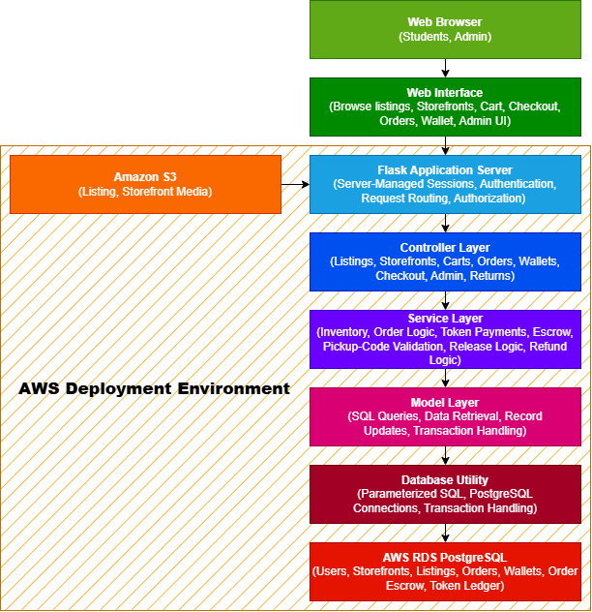
A layered Flask architecture was selected to keep request handling, business rules, and database access in separate components. This organization supports maintainability and testing by limiting the responsibilities of each layer. A serverless architecture and a more tightly coupled application structure were considered but were not selected for the current implementation.
The current deployment target uses AWS services as configured for the project. The suitability of this architecture for larger workloads has not been established unless supported by load testing and deployment measurements.

3.1.2 Alternatives (Chi Martin)
Several alternate architectural approaches were considered during the design of Treasure Row. While from the start it was known it would not be the most useful architecture, a monolithic architecture was an option where all system components operated within a single application. It was chosen because it simplifies development; however, it was quickly realized, given the scope of this project, that it could make the system harder to read, navigate, maintain, and scale.

Another option was a serverless architecture using AWS services such as Lambda, which was also considered. This approach can improve scalability and reduce infrastructure management.

The selected design is a layered Flask application deployed through AWS Elastic Beanstalk. It fits the current project scope and keeps request handling, business rules, and persistence responsibilities distinct. No claim is made that the current deployment has been load-tested for large-scale workloads.

3.2 Description for Web Interface (Chi Martin)
The Web Interface component represents the user interface portion of Treasure Row system. This layer allows students and admins to interact with the marketplace through a web browser. The interface is responsible for displaying listings, storefronts, and account information while capturing user input such as login credentials, listing creation data, and purchase actions.

The interface communicates with the backend application through HTTP requests sent to the Flask API endpoints. Responses returned from the backend are then rendered to users in the form of listings, account information, or confirmation messages.

3.2.1 Processing Narrative (PSPEC) for Web Interface (Chi Martin)
The Web Interface processes user actions and forwards them to the backend server. When a user browses listings, creates a storefront, or places an order, the interface sends a request to the correct backend API endpoint.

The backend processes the request, retrieves or modifies the necessary data, and returns a response that is displayed to the user through the interface.

3.2.2 Web Interface Description (Chi Martin)
The inputs and outputs associated with the Web Interface component are described below.

Inputs to the Web Interface:
- User credentials for authentication (email, username, password)
- Storefront information such as brand name, logo, description, and banner and logo image files
- Listing information entered by brand owners (title, description, price, fulfillment type, and inventory details)
- Listing image files submitted during listing creation, which are uploaded to Amazon S3 via the backend and referenced within the database
- User navigation requests when browsing storefronts and listings
- Search input used to filter and retrieve storefronts in real time
- Order and checkout actions initiated by shoppers, including buyer contact details and meeting location
- Wishlist selections and cart management actions taken by users interacting with marketplace items
- Return request submissions including order number, reason, and optional damage image

The browser interacts with the Flask application through a combination of server-rendered page requests, form submissions, and JavaScript-driven requests. The response format depends on the route: page routes may return rendered HTML or redirects, while API endpoints may return JSON with an appropriate HTTP status code. File uploads use multipart form submissions where required.

The specification should identify the actual method, path, request format, authentication requirement, response format, and relevant error responses for each important endpoint. It should not describe every interaction as a JSON API unless that behavior is confirmed for all listed routes.

Outputs generated by the Web Interface:

- Displays marketplace storefronts and connected listings information retrieved from the backend
- Real-time search results filtering storefronts based on user input
- Confirmation messages when actions such as storefront or listing creations are successful
- Order confirmation page displaying confirmation number, order summary, and total amount
- Error messages when invalid input or unauthorized actions occur
- Updated views of storefronts, listings, cart contents, orders, or wishlist items based on backend responses

The Web Interface sends requests to the Flask backend using standard HTTP methods such as GET, POST, DELETE, and receives responses in JSON format, which are then rendered into visible content within the browser. Overall, the interface allows users to interact with the marketplace system while the backend application handles processing, validation, and data management.

3.2.3 Sub-Component: S3 Image Upload
A detailed algorithmic description of the image upload sub-component within the Web Interface is presented below. This sub-component handles all image file submissions from the user interface to AWS S3 storage and applies across storefront creation, listing creation, storefront editing, listing editing, and return submissions.

3.2.3.1 Interface Description
The image upload sub-component accepts image files submitted by users through the web interface via drag-and-drop zones or file browser inputs. Files are submitted as multipart/form-data to the appropriate backend endpoint. The sub-component outputs a public S3 URL that is stored in the database and rendered back to the user in the interface.

3.2.3.2 Algorithmic Model (e.g., PDL)
- User selects or drags an image file into the upload zone in the browser
- JavaScript captures the file and submits it to the appropriate backend endpoint as multipart/form-data
- Flask receives the file via request.files and validates the file extension
- utils/s3.py generates a unique filename using UUID and uploads the file to the S3 bucket under the appropriate folder (storefronts/, listings/, or returns/damage/)
- The public S3 URL is constructed and returned to the controller as a JSON response
- The URL is stored in the relevant database table and rendered in the interface

3.2.3.3 Restrictions/Limitations
- Requires a valid AWS S3 bucket configured with public read access via bucket policy
- Requires AWS_ACCESS_KEY_ID, AWS_SECRET_ACCESS_KEY, AWS_REGION, and AWS_S3_BUCKET environment variables to be set in the application environment
- Accepted file types: PNG, JPG, JPEG, GIF, WebP only. All other file types are rejected before upload
- Maximum 4 images per listing; 1 banner, 1 logo, and 4 preview images per storefront; 1 damage image per return submission
- Requires a stable network connection between the Flask server hosted on AWS Elastic Beanstalk and the AWS S3 service

3.2.3.4 Local Data Structures
Image files are handled as Flask file objects retrieved from request.files. After a successful upload, the returned S3 URL is stored as a TEXT value in the appropriate database table: listing_images for listing images, storefronts for banner, logo, and preview images, and returns for damaged images. Filenames are generated at runtime using uuid.uuid4().hex combined with the original file extension to ensure uniqueness.

3.2.3.5 Performance Issues
Large image files or multiple simultaneous uploads may increase response times. Each upload requires a round-trip network request from the Elastic Beanstalk server to AWS S3. Upload failures return None from upload_image_to_s3() and are handled with structured error responses returned to the client. Under the AWS Free Tier, bandwidth and request limits may impact upload performance during periods of high activity.

3.2.3.6 Design Constraints
The sub-component is constrained to AWS S3 as the image storage provider, consistent with the overall AWS infrastructure used by the project. Image URLs must be publicly accessible since they are rendered directly in the browser without additional authentication. The upload logic is centralized in utils/s3.py to keep it reusable across the storefront, listing, and return contexts. The sub-component must also remain compatible with the multipart/form-data encoding required for file submissions through HTML forms and JavaScript fetch requests.

3.3 Description for Flask Application Server (Chi Martin)
The Flask Application Server serves as the central processing layer of the Treasure Row system. It receives incoming HTTP requests from the Web Interface and routes those requests to the appropriate controllers for processing.

The server coordinates communication between the user interface, backend application components, database system, and external storage services.

3.3.1 Processing Narrative (PSPEC) for Flask Application Server
When a request is received from the Web Interface, the Flask server determines the appropriate API route and forwards the request to the relevant controller. The controller then processes the request and communicates with other application layers to complete the requested operation.

Once processing is finished, the Flask server sends a structured response back to the Web Interface, allowing the user interface to update the display as needed.

3.3.2 Flask Application Server Interface Description
The Application Server receives HTTP requests from the Web Interface and communicates with backend components to process those requests.

Inputs received by the Flask Server include:
- HTTP requests sent from the Web Interface
- Request headers and cookies required by the HTTP protocol, including the session cookie where applicable. Identity and role are derived from the server-managed session, not from client-supplied identity headers.
- Request payloads containing data related to storefronts, listings, or orders.

Outputs produced include:
- JSON responses containing requested data
- Confirmation responses for successful operations
- Error responses for invalid or unauthorized requests

The Flask server forwards requests to the controller layer, which then interacts with the service and data layers of the application.

3.3.3 Sub-Component Processing Detail
The Flask Application server has several sub-components that handle request routing, application processing, and database interaction. These sub-components include the controller layer, service layer, and model (data access) layer.

To break it down further, when an HTTP request is received, the Flask routing system directs the request to the appropriate controller. The controller validates the request and calls functions in the service layer responsible for performing the requested operation. The service layer is responsible for system functionality and interacts with the model layer to retrieve or store data in the PostgreSQL database.

Once completed, the results or status information is returned to the controller, which formats the response as a JSON object and sends it back through the Flask server to the Web Interface. This layered structure separates responsibilities across components and allows each sub-component to perform a clearly defined role in processing application requests.

3.3.3.1 Interface Description
Each sub-component within the Flask Application Server communicates with other components through clearly defined function calls and data structures.

Inputs into Sub-Components Include:
- HTTP request data sent from the Flask routing system
- Resource identifiers such as storefront IDs, listing IDs, order IDs, and user IDs. Any user ID supplied by the client is treated as input and is not proof that the requester owns that resource
- JSON payload data containing listing, storefront, or order information

Outputs Produced:
- Structured data objects retrieved from the PostgreSQL database
- JSON-formatted responses returned from the controller layer
- Status messages indicating successful operations or errors

Controllers serve as the primary interface between the Flask server and internal processing layers, while the service and model layers provide support for system operations.

3.3.3.2 Algorithmic Model (e.g., PDL)
The following pseudocode:
BEGIN Flask_Server_Request_Handler

Receive HTTP request from Web Interface

Determine requested API route

IF route exists THEN
Forward request to corresponding controller
Controller processes request
Controller calls service layer if business rules are required
Service layer interacts with model layer for database operations
Receive response from controller
Return JSON response with appropriate HTTP status code
ELSE
Return HTTP 404 Not Found
END IF

END

3.3.3.3 Restrictions/Limitations
The Flask server depends on several external system components and infrastructure services to function correctly.

Key elements include:
- A reachable PostgreSQL database configured for the application. The production hosting service must be identified from the active AWS configuration rather than assumed to be RDS
- Valid environment configuration variables for database credentials and service endpoints
- A stable network connection between the Flask Server and the database system
- The presence of required Python libraries and application dependencies

If any of these components are unavailable, certain system operations such as data retrieval, listing creation, or storefront management may fail or return errors.

3.3.3.4 Local Data Structures
The Flask server does not actually maintain internal data structures. It instead primarily handles structured request and response objects provided by the Flask framework. Incoming requests are represented using Flask request objects that contain headers, URL parameters, and JSON payloads. Responses are returned as JSON objects using Flask’s jsonify() utility. These structures allow the application server to pass data between the controller, server, and model layers.

3.3.3.5 Performance Issues
Potential performance issues include concurrent HTTP requests, repeated database queries, large request payloads, and image upload or retrieval latency. These are operational considerations to measure under a defined workload, not proof of a specific bottleneck.
- Collection and retention of buyer contact information
- Storage of real-money payment-card or banking information
- Registration by email addresses outside the permitted Hampton University domains

Checkout records the buyer name, email, contact information, and meeting location required by the current order schema. These fields are personal information and must be collected only for the marketplace workflow, protected from unauthorized access, and retained only as required by the project’s policy. Treasure Row does not process card payments or require bank-account details; real-money payment information is outside the current scope. Registration validation limits eligible email domains, but an email-domain check alone should not be described as independent proof of current student enrollment.

3.3.3.6 Design Constraints
The following design constraints apply to the Flask Application Server and the overall system architecture:
- AWS Deployment Dependency - the application is deployed through AWS Elastic Beanstalk and relies on the services actually configured for database access and image storage. Do not list RDS, IAM, VPC isolation, security-group restrictions, or other specific infrastructure as deployed facts unless the active configuration confirms them.
- AWS Free Tier limitations - the team operates within AWS Free Tier limits, constraining available compute resources, database storage, memory allocation, and concurrent connections. All architectural decisions must account for these resource boundaries.
- Non-Student Account Registration - the system enforces Hampton University email validation at the service layer. Only emails ending in hamptonu.edu or my.hamptonu.edu are permitted to register, restricting marketplace access to verified Hampton University students.
- Cross-Platform Compatibility - the system must function consistently across macOS and Windows and across major web browsers. The frontend is built with standard HTML, CSS, and JavaScript to ensure broad compatibility without reliance on browser-specific features.
- One Storefront Per User - the service layer enforces a rule that each user account may only create one storefront. This constraint is validated in storefront_service.py before any database insertion occurs.
- In-Person Exchange Model - checkout records buyer contact and meeting-location details and uses Treasure Tokens for internal accounting. The application does not process real-money payments or independently verify that an in-person exchange occurred.
- Layered Architecture Enforcement - controllers must not access the database directly. All database operations must flow through the service and model layers to maintain separation of concerns and preserve the integrity of the system architecture.
- Non-student Account Registration (Noah Higgs) - the system enforces Hampton University email validation at the service layer. Only emails ending in hamptonu.edu or my.hamptonu.edu are permitted to register, restricting marketplace access to verified Hampton University students. The service also requires a username of 3 to 50 characters and a password of 8 to 128 characters.

3.3.3.7 Checkout and Treasure Tokens Processing
The checkout service retrieves trusted listing prices and validates requested quantities and available inventory before committing the order. It checks the buyer's Treasure Token balance and performs the required wallet, order, order-item, escrow, ledger, and inventory operations within the applicable database transaction boundaries. Wallet locking and transaction handling must prevent concurrent checkouts from spending the same available balance. If checkout fails, the system must roll back the affected transaction so that no partial token debit, escrow hold, or incomplete order is reported as successful.
Each seller's portion of an order is represented by an escrow record. The pickup code is provided to the buyer and is validated when the authorized seller submits it to confirm pickup. A successful confirmation releases the applicable escrow according to the implemented state-transition rules. Cancellation or administrative refund operations return eligible held tokens to the buyer and record the corresponding ledger activity. Repeated release attempts and invalid or locked pickup-code attempts must be rejected.

3.4 Description for Controller Layer (Chi Martin)
The Controller Layer exposes application routes through Flask Blueprints. Controllers parse incoming HTTP requests, obtain authenticated identity from the server-managed Flask session where required, invoke the appropriate service-layer operation, and return an HTTP response or render a page.
Protected page routes redirect unauthenticated users to the sign-in page. Protected API endpoints return an unauthorized response when authentication is missing. Authorization checks are performed using the authenticated user's identity and role, together with the relevant ownership and business rules.
Client-supplied identity headers, including X-User-Id and X-User-Role, are not trusted as sources of authentication or authorization. A request cannot gain another user's permissions by changing these headers. The service layer must validate resource ownership and role-based permissions before any protected operation is performed.
Controllers must not perform database operations directly. Database access is delegated through the service and model layers.
The exact session fields, route-level access rules, HTTP status codes, and controller responsibilities must be kept consistent with the current implementation and regression tests.

3.4.1 Processing Narrative (PSPEC) for Controller Layer
For each incoming request, the controller identifies the route, parses submitted data, and calls the relevant service function. Authentication and authorization must be enforced before a protected operation is allowed to modify data. The controller returns an HTML page, redirect, JSON payload, or error response as appropriate for that route.
For page routes and session-protected endpoints, the controller checks the Flask session for the presence of session['user'], session['user_id'], and session['role'] to verify that the user is authenticated. If the session is missing or invalid, the user is redirected to the login page. This is the primary authentication mechanism used throughout the application, established when a user successfully logs in through auth_controller.py.
For direct API endpoints, the controller uses a secondary helper function get_current_user() that reads X-User-Id and X-User-Role request headers to identify the requesting user. This approach supports direct API access and testing outside of the browser session context.
The controller parses incoming request data using request.get_json(silent=True) for JSON payloads or request.form for multipart form submissions including file uploads. The controller then calls the corresponding service function, passing the current user, any route parameters such as storefront_id or listing_id, and the parsed input data. The service layer performs all rule enforcement and database operations through the model functions.
A successful service call returns the result as JSON using jsonify() along with the correct HTTP success status code. If an error occurs, the controller catches the exception and returns a structured JSON error message. Errors are mapped to status codes based on the type of failure: 401 for unauthorized, 403 for forbidden, 404 for missing resources, and 400 for invalid input.

3.4.2 Controller Layer Interface Description
The Inputs and outputs received by controllers include:
Inputs:
- HTTP requests routed to the appropriate blueprint (POST, GET, PUT, PATCH, DELETE)
- URL parameters such as storefront_id, listing_id, user_id, and return_id
- JSON request bodies containing data for create and update actions
- Multipart form data containing image file uploads for listings, storefronts, and returns
- Flask session data containing user identity (session['user'], session['user_id'], session['role'])
- Request headers containing X-User-Id and X-User-Role for direct API access

Outputs:
- Structured JSON responses returned to the Flask server
- Error responses when validation or permission checks fail
- HTTP status codes that indicate success or failure
- Page redirects when session authentication fails on protected routes

3.4.3 Sub-Component Processing Detail
The following sub-components represent key controller endpoints implemented for functionality.

3.4.3.1 Create Listing
Inputs:
- HTTP Method: POST
- Route: /api/listings/create
- Session: session['user_id'] (required)
- Form Data (multipart/form-data):
- title, price, fulfillment_type, status
- sizes_available (JSON string array)
- size_quantities (JSON object mapping size to quantity)
- quantity_on_hand (calculated from size quantities)
- is_made_to_order (boolean)
- listing_images (up to 4 image files, uploaded to S3)
Outputs:
- HTTP 201 + JSON listing record on success
- HTTP 401 if no valid user header exists
- HTTP 403 if user lacks permission
- HTTP 404 if storefront does not exist
- HTTP 400 for validation errors
- HTTP 500 if S3 image upload fails

3.4.3.2 Algorithmic Model (e.g., PDL)
The following pseudocode represents the logic used by the controller when handling a listing creation request. The pseudocode reflects behavior implemented in listing_controller.py, storefront_controller.py, and all other files in the controller folder where the controller validates the requesting user, parses request data, calls the service layer, and returns the resulting JSON response.

FUNCTION create_listing_from_form():

current_user = get_current_user_from_session()
IF current_user is None:
RETURN 401 Unauthorized

user_storefront = get_my_storefront_service(current_user)
IF user_storefront is None:
RETURN 400 "You must create a storefront before creating listings"

PARSE form fields: title, price, fulfillment_type, status,
sizes_available, size_quantities, is_made_to_order

IF title is empty:
RETURN 400 "title is required"

IF sizes_available is empty:
RETURN 400 "At least one size must be selected"

IF no image files submitted:
RETURN 400 "At least one listing image is required"

IF more than 4 image files submitted:
RETURN 400 "You can upload up to 4 listing images"

FOR each image file:
IF invalid file type:
RETURN 400 "Invalid file type"
image_url = upload_image_to_s3(file, folder="listings")
IF upload fails:
RETURN 500 "Failed to upload image to S3"
APPEND image_url to image_urls

quantity_on_hand = SUM of all size quantities

listing = create_listing_service(current_user, storefront_id, data)

FOR each image_url in image_urls:
add_listing_image_service(current_user, listing_id, image_url, is_primary=(index == 0))

FOR each size in sizes_available:
upsert_listing_size_service(current_user, listing_id, size, size_quantity)

RETURN 201 + JSON listing record

3.4.3.3 Restrictions/Limitations
The Create Listing controller endpoint requires a valid authenticated session. If the user is not logged in, the request cannot continue.
The user must also have an existing storefront before creating a listing. This endpoint depends on the service layer to enforce permission rules such as storefront ownership and administrator privileges. Successful execution additionally requires the database connection, model layer, and AWS S3 service to be available to complete the required operations.

3.4.3.4 Local Data Structures
The controller layer uses Flask request data and structured responses. For listing creation, fields may be read from request.form and uploaded images from request.files. The controller obtains the current user from the server-managed Flask session and passes the authenticated identity and parsed data to the service layer. Client-supplied user IDs or role headers must not override that identity.
User identity is retrieved from the Flask session using session['user_id'] and passed to service functions as a current_user dictionary containing id and role. These structures are passed to the service layer for validation and processing.

3.4.3.5 Performance Issues
Possible performance issues for the controller layer include the number of incoming HTTP requests and the size of the requests. If a large number of requests are received at the same time, the server may experience increased response times. For the Create Listing endpoint specifically, uploading multiple image files to AWS S3 within a single request adds additional processing time, as each file requires a separate round-trip upload operation. Large image files or slow network conditions between the Elastic Beanstalk server and S3 could further affect response times. Proper request validation, efficient routing, and minimization of unnecessary data processing help ensure the controller layer remains responsive.

3.4.3.6 Design Constraints
The main design constraint is that the controller layer must follow the layered architecture created for the system; therefore, it cannot directly access the database. All database operations must occur through the service and model layers. Controllers are simply responsible for request parsing, routing, and returning structured responses. Additionally, it must maintain compatibility with Flask and support REST-style API endpoints using HTTP methods. Additionally, file upload handling must remain compatible with multipart/form-data encoding and AWS S3 via utils/s3.py, and session-based authentication must be checked on all protected routes before any processing occurs.

3.4.3.7 Messaging Endpoints (Jonah Goodwine)
The messaging controller (controllers/message_controller.py) lets a signed-in buyer and seller message each other about a listing. It is registered as message_bp in app.py.
Inputs:
- POST /api/messages: send a message. JSON body: receiver_id, listing_id (optional), body (1 to 1000 characters)
- GET /api/messages: the signed-in user's conversations, newest first
- GET /api/messages/<other_id>?listing=<listing_id>: one conversation, oldest message first
- GET /messages: the Messages page (messages.html)
- Session: the sender is always the signed-in user from the session, never a value sent by the browser
Outputs:
- HTTP 201 + JSON {"id"} when a message is saved
- HTTP 200 + JSON list of conversations (other user, listing title, last message, time, unread count)
- HTTP 200 + JSON conversation; opening it marks the messages sent to the user as read
- HTTP 401 if signed out (sign-in check in app.py); the page redirects to Sign In
- HTTP 403 if the session has no user id (the admin account from .env)
- HTTP 400 for an empty message, over 1000 characters, messaging yourself, or a non-numeric id
- HTTP 404 if the receiver or listing does not exist

3.4.3.8 Algorithmic Model (PDL): Send Message (Jonah Goodwine)
The following pseudocode represents the logic used by the controller when a user sends a message.
FUNCTION send_message():

my_id = user id from the session
IF my_id is None:
RETURN 403 "Sign in with a user account to use messages."

data = JSON request body
body = data.body with spaces trimmed
TRY:
receiver_id = integer(data.receiver_id)
listing_id = integer(data.listing_id), or None if blank
EXCEPT not a number:
RETURN 400 "Invalid receiver or listing."

IF body is empty: RETURN 400 "Message can't be empty."
IF length(body) > 1000: RETURN 400 "Message is too long (1000 characters max)."
IF receiver_id == my_id: RETURN 400 "You can't message yourself."
IF receiver does not exist: RETURN 404 "User not found."
IF listing_id is not None AND listing does not exist:
RETURN 404 "Listing not found."

new_id = message_model.send_message(my_id, receiver_id, listing_id, body)
RETURN 201 {"id": new_id}

3.4.3.9 Restrictions/Limitations: Messaging (Jonah Goodwine)
Messaging requires a signed-in user account. The admin login from .env has no user id, so it cannot send or read messages. Messages cannot be edited or deleted after they are sent, and there are no email or push notifications.
Messages are not pushed to the browser. The Messages page checks for new messages every 10 seconds, so a reply can take up to 10 seconds to appear.

3.4.3.10 Performance Issues and Design Constraints: Messaging (Jonah Goodwine)
Each open Messages page sends one request every 10 seconds, and the conversation list is built from all of the user's messages on every request. This is fine at class-project scale; with many users it would need pagination, indexes on sender_id and receiver_id, or WebSockets instead of polling.
Messaging follows the same layered pattern as the rest of the app: routes in the controller, SQL in models/message_model.py with parameterized queries, and message text escaped with escapeHtml before it is shown, so typed HTML or scripts appear as plain text.

3.5 Description for Service Layer (Chi Martin)
The Service Layer applies application rules, validates input, and enforces authorization before asking the model layer to read or change persistent data. It verifies the authenticated user, resource existence, ownership, role permissions, and operation-specific constraints. It must not treat a user ID in a request body or header as sufficient evidence of identity.

The service layer contains operations for authentication, storefronts, listings, checkout, wishlists, purchases, returns, and administration. A table’s or service file’s existence does not establish that the associated user-facing feature is complete; feature status must reflect the implemented routes and interface.

3.5.1 Processing Narrative (PSPEC) for Service Layer
More specifically, when a controller calls a listing service function, the service first verifies that a valid current_user exists. The service then checks and confirms that the relevant resource exists, such as verifying the storefront exists before creating a listing, or verifying that the listing exists before updating images or size inventory. After confirming that it exists, the service enforces authorization rules by ensuring the requesting user is a storefront owner associated with the listing or an admin.

The service validates required fields and value ranges, including listing title, price, fulfillment type, and inventory. For checkout, it verifies current server-side prices and availability, validates buyer details and token balance, and invokes the transaction-aware checkout workflow. Inventory updates, cart clearing, and wishlist changes must be described according to actual code paths; they must not be assumed to be atomic unless they are inside the same database transaction.

After successful validation and authorization, the service calls model functions to execute database queries. The model returns structured records, which the service returns to the controller.

3.5.2 Service Layer Interface Description
The inputs received by the service layer include:
- Current_user object containing user ID and role
- Resource identifiers such as storefront_id, listing_id, image_id, return_id, and order_id
- Processed request data forwarded from controllers, including listing attributes, storefront fields, buyer details, and cart contents
- User identification information used for permission validation
- Image URLs returned from S3 uploads passed through from the controller layer
- Session cart data passed to the checkout service for order processing

Outputs produced by the service layer include:
- Created or updated records returned as dictionaries
- Lists or records for retrieval functions
- Order records including confirmation number, order items, and total amount
- Errors when requests are invalid, unauthorized, or missing.

3.5.3 Sub-Component n.m Processing Detail
The following sub-components represent key service operations implemented in listing_service.py. But these operations are implemented similarly in practically every service layer file, including storefront, checkout, wishlist, returns, and admin services. The listing service functions manage all listing-related operations within the marketplace. IT handles actions such as creating and updating listings, adding images to listings, and managing size-based inventory records. Each operation begins by verifying that the user is authenticated and authorized to modify the resource. The service confirms that the listing and its associated storefront exist and ensures that the requesting user is either the storefront owner or an admin. After authorization checks, the service validates input data to confirm required fields are present and that values are correctly formatted. This includes validating listing attributes such as title, price, fulfillment type, description, quantity, and image URLs. Once validation is complete, the service calls the appropriate model-layer function to execute the database operation. The resulting record is then returned to the controller layer, which fronts the response for the client.

3.5.3.1 Interface Description
The service layer receives validated request data and user information from the controller layer. Inputs include the current_user object, identifiers such as storefront_id or listing_id, and request data containing lifting attributes, image URLs, size inventory values, or buyer details depending on the operation. Outputs from the service layer include structured records representing created or updated data, lists of retrieved objects, or error responses when operations fail.

3.5.3.2 Algorithmic Model (e.g., PDL)

FUNCTION create_listing_service(current_user, storefront_id, data):

IF current_user is None:
RAISE "Unauthorized"

storefront = get_storefront_by_id(storefront_id)
IF storefront is None:
RAISE "Storefront not found"

IF storefront.owner_id != current_user.id AND current_user.role != "admin":
RAISE "Unauthorized action"

VALIDATE title, price, fulfillment_type from data
IF fulfillment_type == "IN_STOCK":
VALIDATE quantity_on_hand >= 0
IF fulfillment_type == "PREORDER":
SET quantity_on_hand = None

listing = create_listing(storefront_id, validated data)
RETURN listing

3.5.3.3 Restrictions/Limitations
Service operations require the appropriate authenticated user and a reachable, initialized database. Operations also depend on the specific resource and input requirements. Checkout requires a non-empty valid cart and the required buyer information. An operation must return an error when its prerequisites fail and must not claim success unless the corresponding persistent changes succeed.

3.5.3.4 Local Data Structures
The service layer primarily uses dictionary-style data structures for representing user information (current_user) and request data (data). These structures contain listing attributes, image URLs, or size inventory values depending on the operation being performed. The checkout service additionally uses a list of session cart item dictionaries to calculate order totals and create order item records.

3.5.3.5 Performance Issues
Service layer performance can be affected by the number of sequential database calls required to complete a single operation. For example, creating a listing with multiple images and sizes requires separate model calls for the listing record, each image, and each size entry. The checkout service performs multiple sequential operations including creating the order, creating order items, decrementing size inventory, clearing the cart, and removing purchased items from the wishlist. These operations are executed in sequence and could be affected by database response times under load.

3.5.3.6 Design Constraints
The service layer must enforce authorization rules consistently across all listing operations and must not allow controllers to directly access the database. All database interactions must occur through model-layer functions to preserve the layered architecture of the system. Additionally, the service layer must also rely on the model layer for all SQL execution and connection handling.

3.6 Description for Data Model and Database Access Layer (Chi Martin)
The Data Model Layer manages communication between the application and the database. This layer is responsible for executing SQL queries and retrieving or modifying records within the database.

3.6.1 Processing Narrative (PSPEC) for Data Model and Database Access Layer
This layer is important when the service layer requires data retrieval or modification. It sends requests to the data model layer, and it executes the necessary SQL queries and returns the resulting records to the service layer.

3.6.2 Data Model and Database Access Layer Interface Description
The inputs received by the model layer include:
- Data requests forwarded from the service layer
- Query parameters used to identify database records
- ​​Structured data representing new or updated records to be inserted or modified in the database

Outputs produced by the model layer include:
- Database query results returned as structured data in dictionary format
- Confirmation of successful database insertions, updates, or deletions
- Error messages if database operations fail

The model layer communicates with PostgreSQL through the database adapter used by the application. The specific production database host or managed service must be verified in deployment configuration; this document does not assume AWS RDS solely because the application is deployed on AWS.

3.6.3 Sub-Component n.m Processing Detail
The Data Model and Database Access Layer is composed of multiple model modules responsible for interacting with specific database tables. These sub-components correspond to core system entities such as users, storefronts, listings, listing sizes, listing images, purchases, wishlists, cart items, orders, order items, and returns.
Each model module contains functions that execute SQL queries to retrieve, insert, update, or delete records within the PostgreSQL database. These functions are called by the service layer when application operations require database interaction.
When a request is received from the service layer, the appropriate model function constructs and executes the required SQL query using the database connection. The results of the query are then formatted into structured data objects and returned to the service layer for further processing.
This design isolates database interaction within the model layer, ensuring that application logic remains separate from direct database operations.

3.6.3.1 Interface Description
The model sub-components provide a programmatic interface for accessing and modifying database records.
Inputs include:
- Data requests forwarded from the service layer
- Query parameters such as user IDs, storefront IDs, listing IDs, order IDs, return IDs, and confirmation numbers
- Structured data representing new or updated database records
Outputs include:
- Database query results returned as structured data objects
- Confirmation responses indicating successful record creation or modification
- Error information when database operations fail or return invalid results
Model functions act as the primary interface between the application and the PostgreSQL database system.

3.6.3.2 Algorithmic Model (e.g., PDL)

FUNCTION create_listing(storefront_id, title, price, fulfillment_type,
quantity_on_hand, status, description, is_made_to_order):

conn = get_connection()
cur = conn.cursor()

EXECUTE SQL:
INSERT INTO listings (storefront_id, title, price, fulfillment_type,
quantity_on_hand, status, description, is_made_to_order)
VALUES (storefront_id, title, price, fulfillment_type,
quantity_on_hand, status, description, is_made_to_order)
RETURNING all fields

result = cur.fetchone()
conn.commit()
cur.close()
conn.close()

RETURN result as dictionary

3.6.3.3 Restrictions/Limitations
The Data Model and Database Access Layer depends on several external components to function properly.
Key requirements include:
- A reachable PostgreSQL database configured through the application environment. Whether the production instance is AWS RDS or another PostgreSQL deployment must be confirmed from the active configuration.
- Valid database credentials and environment variables configured within the Elastic Beanstalk application environment
- A network path and credentials that permit the application to connect to the configured PostgreSQL instance. Exact security-group rules, subnets, and port exposure must be verified rather than inferred.
- Proper database schema initialization via init_db.py including the required tables and relational constraints
If these requirements are not met, database operations may fail, resulting in error responses being returned to the service layer.

3.6.3.4 Local Data Structures
The Data Model Layer operates primarily on relational data structures defined within the PostgreSQL database schema. These structures represent the core entities of the system, including user accounts, storefronts, product listings, inventory, shopping carts, orders, returns, and the Treasure Token payment system.
Key database tables include:
- users - stores user account information, including username, password value, email, role, and account creation timestamp.
- storefronts - stores storefront ownership and configuration data, including brand name, bio, logo, banner, contact information, preview images, categories, activation status, and timestamps.
- listings - stores product listing information, including title, description, price, fulfillment type, available inventory, listing status, and creation and update timestamps.
- listing_sizes - maintains size-specific inventory quantities for individual listings and enforces uniqueness for each listing-size combination.
- listing_images - stores image URLs associated with listings, including a flag identifying the primary image.
- purchases - provides a structure for recording purchase history, including the user, listing, quantity, purchase price, and purchase date. The associated frontend functionality is identified as unfinished in the database initialization script.
- wishlist - stores user-saved listings and prevents duplicate entries for the same user-listing combination. The associated frontend functionality is identified as unfinished in the database initialization script.
- cart_items - stores persistent shopping cart entries associated with users, including item name, price, quantity, and selected size.
- orders - stores checkout order information, including the buyer, unique confirmation number, buyer contact details, meeting location, total amount, order status, and creation timestamp.
- order_items - stores individual line items associated with orders, including listing reference, item name, quantity, purchase-time price, and selected size.
- returns - stores return requests, including the requesting user, order number, reason, damage status, optional damage image URL, request status, timestamps, and soft-deletion flag.
- wallets - stores each user's Treasure Token balance, along with wallet creation and update timestamps. Each user can have at most one wallet, and the balance is constrained to be nonnegative.
- order_escrow - stores Treasure Token amounts held for individual sellers' portions of an order. Records include the order, buyer, seller, escrow amount, escrow status, pickup-code nonce, failed-attempt counter, creation timestamp, and resolution timestamp. Supported statuses include HELD, RELEASED, REFUNDED, and LOCKED. A unique constraint prevents multiple escrow records for the same order and seller.
- token_ledger - records Treasure Token balance transactions, including the associated user, signed transaction amount, transaction type, optional order and escrow references, note, creator identifier, and timestamp. Supported transaction types include STARTING_BALANCE, ADMIN_GRANT, ESCROW_HOLD, ESCROW_RELEASE, and ESCROW_REFUND.
These relational tables are connected through primary and foreign key relationships to maintain data integrity across the system.

3.6.3.5 Performance Issues
Several factors may impact the performance of the Data Model and Database Access Layer.
Database query efficiency can affect response times, particularly when retrieving large sets of listing or storefront data. Proper indexing of frequently queried fields, such as listing IDs or storefront IDs, can improve query performance.
Database network latency may affect response time. If the active deployment uses AWS RDS, measure latency and verify the associated network configuration; otherwise, document the actual database host and connection path.
The checkout process requires multiple sequential database calls, including creating the order record, inserting order items, decrementing size inventory, clearing the cart, and removing purchased items from the wishlist. Each of these operations requires a separate database interaction, which could affect response times under load.
Additionally, inefficient queries or repeated database calls may increase processing time and resource usage, potentially affecting overall system performance.

3.6.3.6 Design Constraints
The design of the Data Model Layer is constrained by several system-level considerations.
The application must operate with a PostgreSQL relational database system, requiring SQL-based data access and adherence to relational schema design principles.
Database communication must be compatible with the Python database adapter used by the application (such as psycopg2), which defines how queries are executed and how results are returned.
The database schema is initialized and updated through init_db.py, which includes CREATE TABLE IF NOT EXISTS statements and selected ALTER TABLE ... ADD COLUMN IF NOT EXISTS statements. Because startup-time schema changes are not a substitute for a controlled migration process, the deployed schema should be checked against the source and any future changes should be managed and verified deliberately.
The model layer must also maintain compatibility with the surrounding application architecture, including the controller and service layers that depend on structured database results for application processing.

3.6.3.7 Token Model and Database Access
The token subsystem persists wallet balances in wallets, per-seller held funds in order_escrow, and token movements in token_ledger.
The wallet model provides the database operations required to create or retrieve wallets, access balances, and record token movements. The service layer enforces business rules for grants, checkout holds, releases, cancellations, refunds, and pickup-code validation. Controllers expose the corresponding user and administrative operations through authenticated routes.
A wallet balance cannot be negative. Checkout locks the buyer's wallet row while performing the balance-sensitive operation. The debit, escrow records, and associated ledger entries are written transactionally so that a failed hold does not leave an incomplete token transfer.
The ledger is the audit history of token movements. The implementation and automated tests require wallet balances to remain consistent with the corresponding ledger totals. Administrative grants must record the responsible administrator, and pickup codes must not be stored in plaintext or disclosed to sellers.
Database column definitions, key relationships, indexes, and SQL constraints are specified in the physical schema inventory. This subsection documents the responsibilities and invariants of the token subsystem rather than duplicating the full SQL schema.

3.6.3.8 Message Model (Jonah Goodwine)
models/message_model.py holds all of the SQL for messaging. Every query uses psycopg2 parameters (%s), never string formatting.
- get_username(userId): returns a user's username, or None if the user does not exist
- get_listing_title(listingId): returns a listing's title, or None if the listing does not exist
- send_message(senderId, receiverId, listingId, body): inserts one message and returns its new id
- get_all_for_user(userId): every message the user sent or received, newest first, joined with both usernames and the listing title
- get_thread(userId, otherId, listingId): one conversation, oldest first
- mark_read(userId, otherId, listingId): marks the messages sent to the user in that conversation as read
get_thread and mark_read compare the listing with IS NOT DISTINCT FROM so that a conversation with no listing (listing_id is NULL) still matches correctly, since NULL = NULL is not true in SQL.

3.6.3.9 Authentication and Cart Model (Jonah Goodwine)
models/auth_model.py holds the SQL that auth_controller.py used to run inline, so the auth controller follows the same controller-to-model pattern as the rest of the app.
- get_user_by_username(username): returns the user row used to check a sign-in
- get_listing_availability(itemId): returns a listing's status and quantity before it is added to the cart
- add_cart_item(userId, itemId, itemName, price, quantity, size): saves one cart line
- remove_cart_item(userId, itemName, size): removes one cart line

3.7 Software Interface Description (Chi Martin)
The software's interface(s) to the outside world are described.

3.7.1 External Machine Interfaces (Chi Martin)
Interfaces to other machines (computers or devices) are described.

- The application uses the PostgreSQL adapter configured in its database-access code. The actual connection host, port, TLS settings, and network restrictions must be taken from the active deployment configuration. The conventional PostgreSQL port is 5432, but this specification does not claim that the production connection uses a particular port or security-group arrangement without verification.

3.7.2 External System Interfaces (Chi Martin)
Interfaces to other systems, products, or networks are described.

- PostgreSQL Database: The application stores relational data in PostgreSQL. The specific hosting service (for example, AWS RDS or a PostgreSQL instance managed by the team), connection endpoint, network path, and security controls must be verified from the deployed environment before being stated as facts.
- AWS Elastic Beanstalk: Confirmed as the application deployment platform. The precise environment settings, load-balancing arrangement, TLS termination, and scaling behavior depend on the configured environment and should be documented from the deployment console or configuration files.
- AWS IAM: IAM permissions are relevant to AWS resources accessed by the application. The specific role, policy, and credential arrangement must be verified. Credentials must not be embedded in source code or included in this specification.
- AWS Networking: A VPC, subnet layout, and private database connectivity should be documented only when confirmed by the active AWS configuration.
- Network Access Controls: Security-group and firewall rules should be documented from the deployed configuration, including which sources can reach the database and which ports are open. Do not claim the database is reachable only from Elastic Beanstalk unless this has been verified.
- Internet Browser: The browser communicates with Flask over HTTP or HTTPS according to the environment. The application returns server-rendered HTML pages and may return JSON for routes that support asynchronous or API-style interactions.
- Verified AWS Deployment (Jonah Goodwine): The app runs on the Elastic Beanstalk environment treasurerow-env in us-east-2: a single t3.micro instance with no load balancer, Python 3.14 on Amazon Linux 2023, served by Gunicorn behind nginx. The database is the RDS PostgreSQL instance treasurerow-db and images are stored in S3, both in us-east-2. Secrets (database password, AWS keys, SECRET_KEY and admin login) are set only as Beanstalk environment properties; app/.ebextensions/env.config sets only DB_PORT, DB_SSLMODE and AWS_REGION, and app/.platform/nginx/conf.d/upload_size.conf raises the upload limit to 25 MB.
- Verified Network Access (Jonah Goodwine): The RDS security group treasurerow-db-sg allows PostgreSQL (port 5432) only from the Elastic Beanstalk server's security group, approved team member IP addresses, and the Hampton campus range, and every rule has a description. 0.0.0.0/0 is never allowed. Steps to get access, troubleshoot, redeploy and shut down are in docs/aws-runbook/README.md.
- Verified S3 Access (Jonah Goodwine): The app uploads and reads images with a dedicated IAM user (treasurerow-app) whose policy only allows putting and getting objects in the Treasure Row image bucket. Its keys are set only in .env files and Beanstalk environment properties.

3.7.3 Human Interface (Chi Martin)
- Web interface: Users access Treasure Row through a web browser using the URL configured for the relevant environment. The development environment and production deployment may use different URLs and transport-security configurations. The current production URL and verification status should be recorded separately from the local development address.
- Administrative interface: Administrative operations are provided through the application's authorized web routes. Database initialization and schema-management scripts are developer/deployment utilities, not a substitute for an administrative user interface.
- Production URL (Jonah Goodwine): http://treasurerow.us-east-2.elasticbeanstalk.com (verified October 27, 2026; HTTP, no custom domain or HTTPS certificate yet). Local development runs at http://127.0.0.1:5001.

4.0 User Interface Design
Treasure Row provides a browser-based interface for marketplace users and administrators. The interface uses server-rendered HTML templates, CSS, and JavaScript. It does not rely on a dedicated frontend framework, according to the current project technology inventory.
The interface supports public-facing entry and sign-in pages, storefront browsing, listing management, wishlist and cart operations, checkout, account management, order history, returns, and administrative operations. Authenticated views expose only the actions permitted to the current user.
The current interface follows the Treasure Row HamptonU Experience design. The final specification must include screenshots captured from the implemented application, with each screenshot identifying the page, user role, and relevant interaction state.
For each screen, the specification must document its primary controls, required inputs, available actions, navigation destinations, validation feedback, loading or failure states, and authorization requirements. Screenshots and descriptions must be updated when the implemented interface changes.

4.1 Description of the User Interface (Chi Martin)

A detailed description of the user interface, including screen images or a prototype, is presented. The program uses a regal/scholarly theme; the terminology is fairly modern, and the primary colors are red, green, and gold.

4.1.1 Screen Images (Chi Martin)
Representation of the interface from the user's point of view.

  Figure 1: Default Screen | 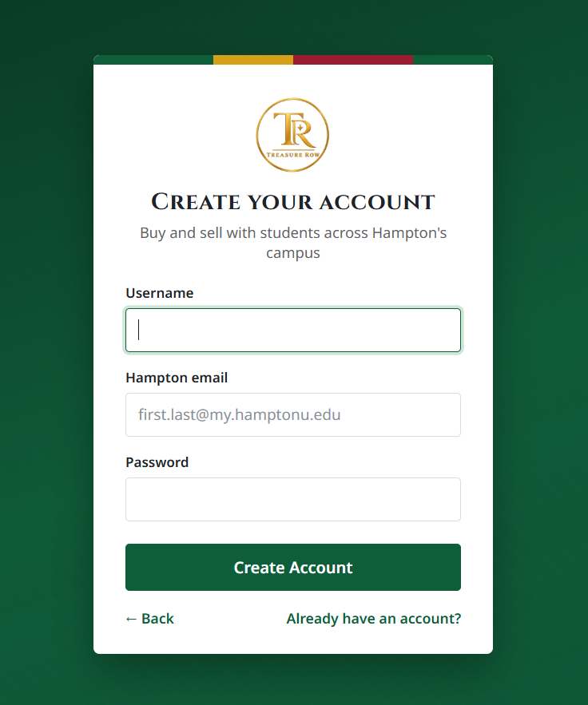  Figure 2: Signup Screen
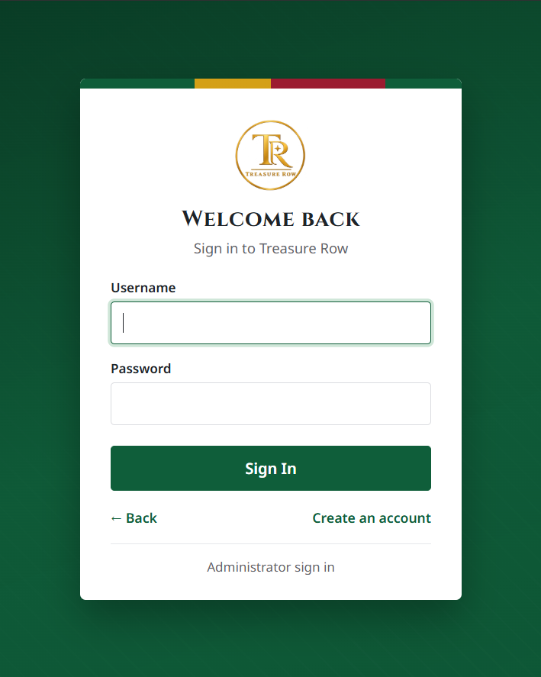  Figure 3: Login Screen | 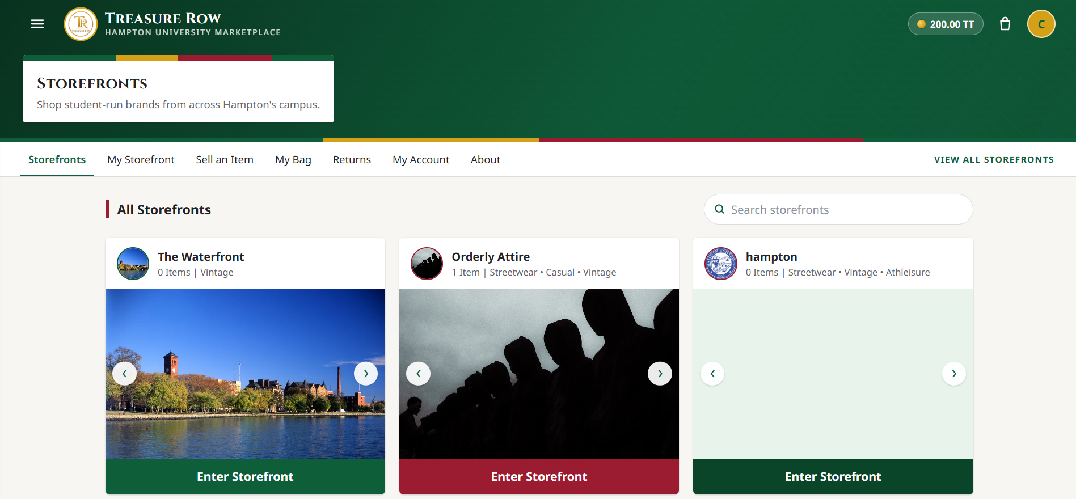  Figure 4: Storefront Homepage (Main)
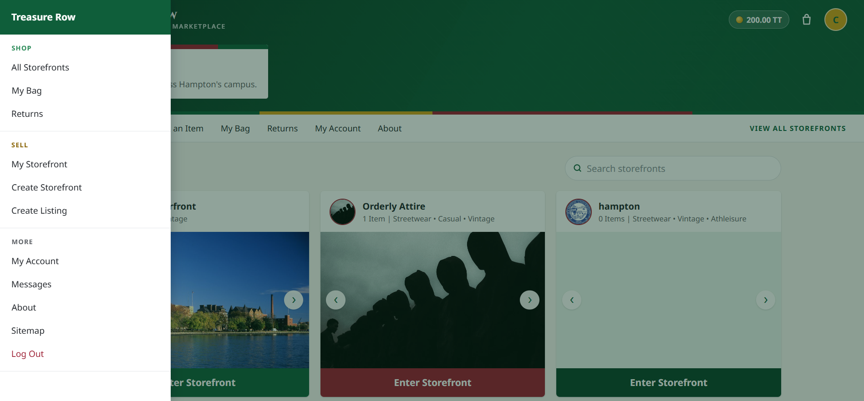  Figure 4.1: Storefront Homepage Navigation Tab | 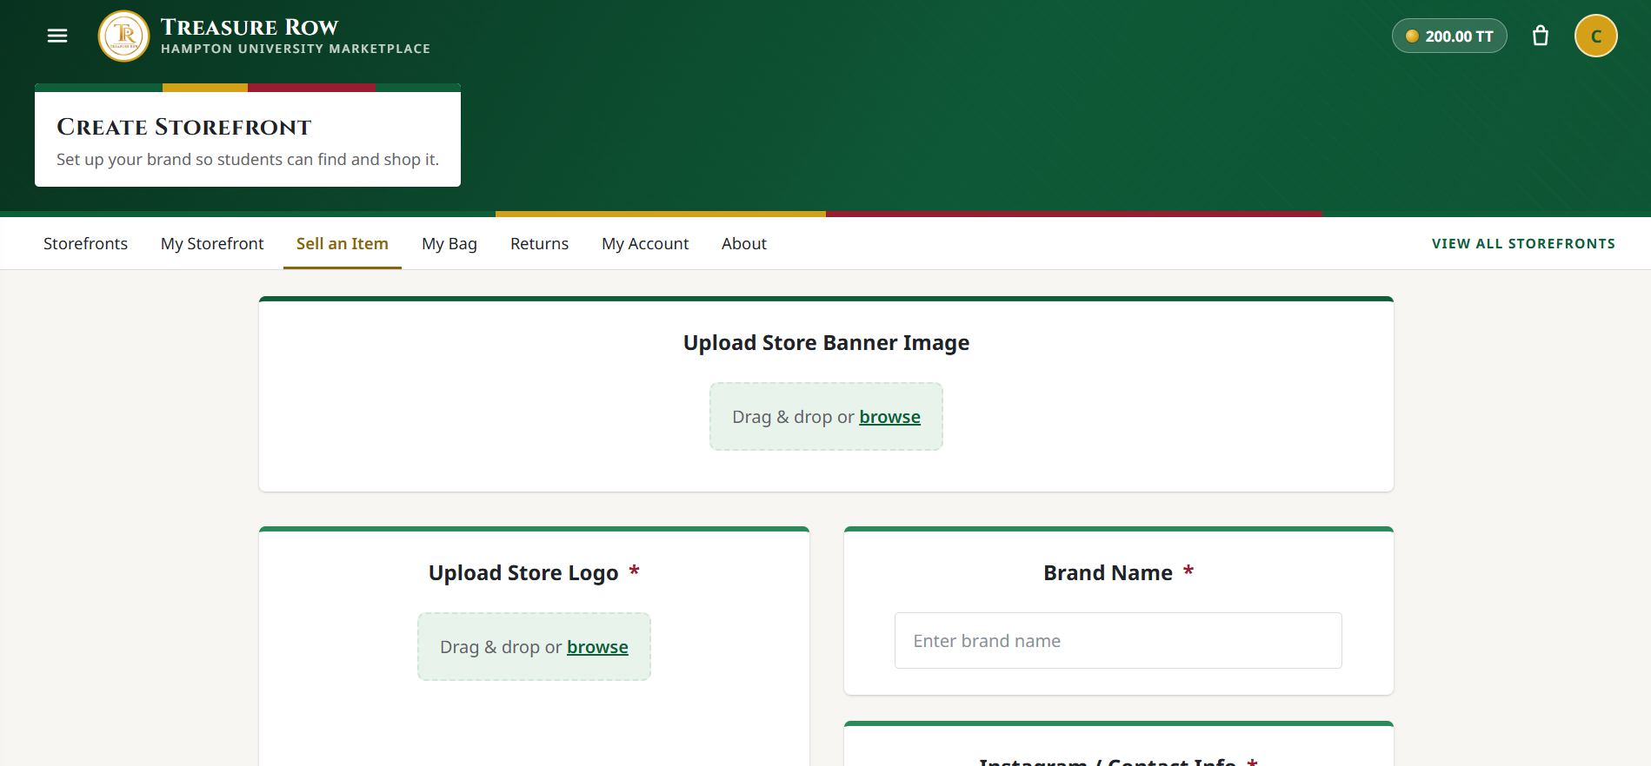  Figure 5: Create Storefront Screen
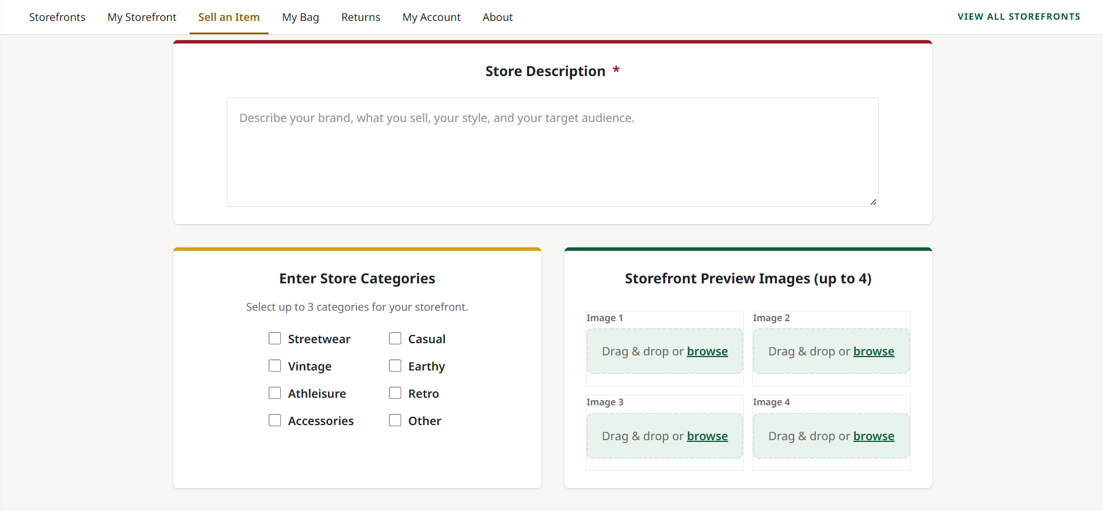  Figure 5.1: Create Storefront Screen | 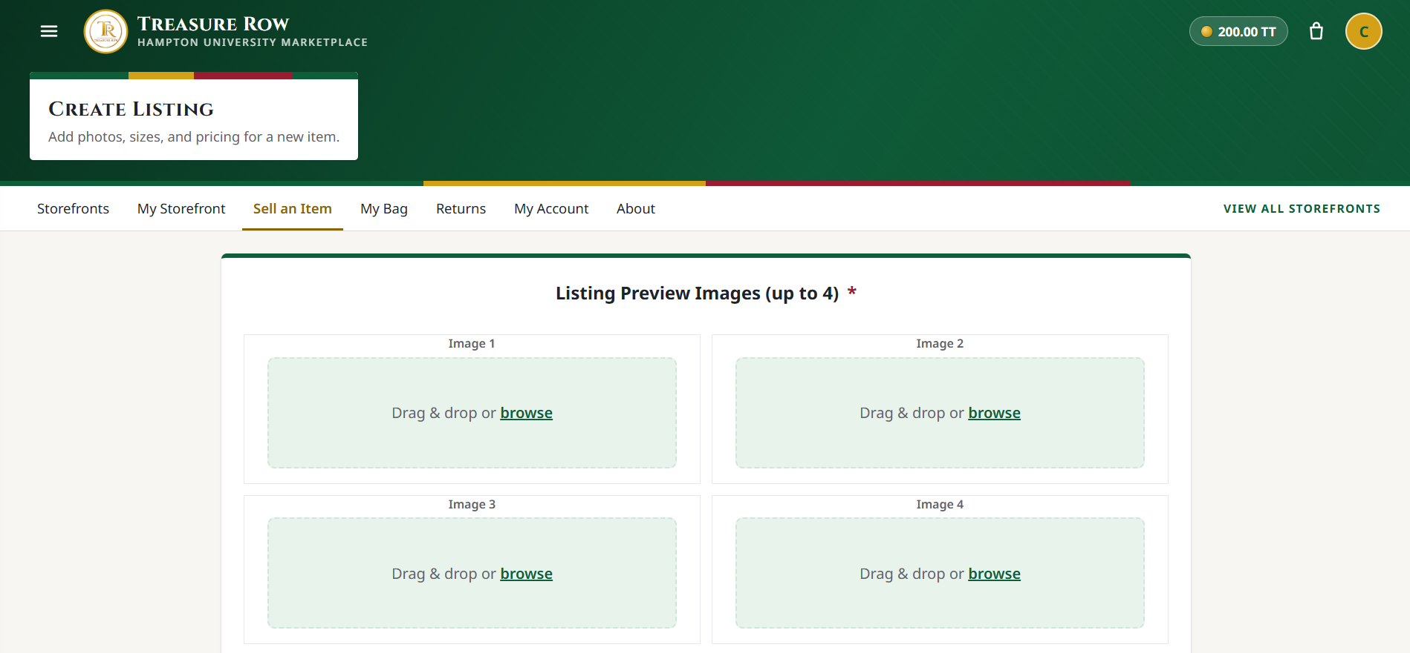  Figure 6: Create Listing Screen
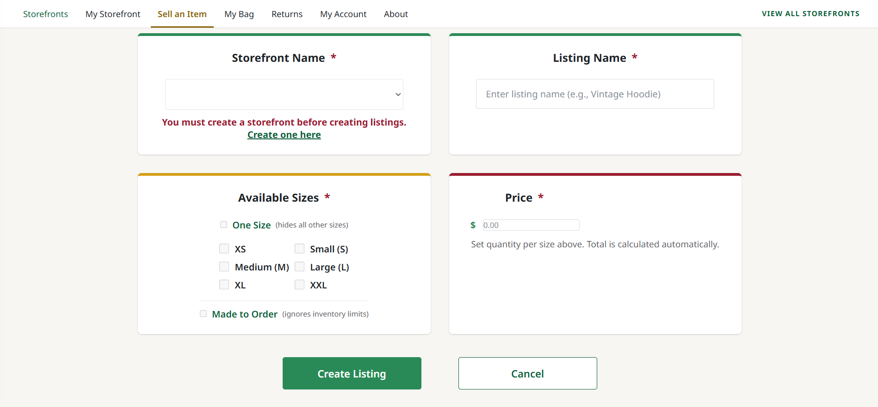  Figure 6.1: Create Listing Screen | 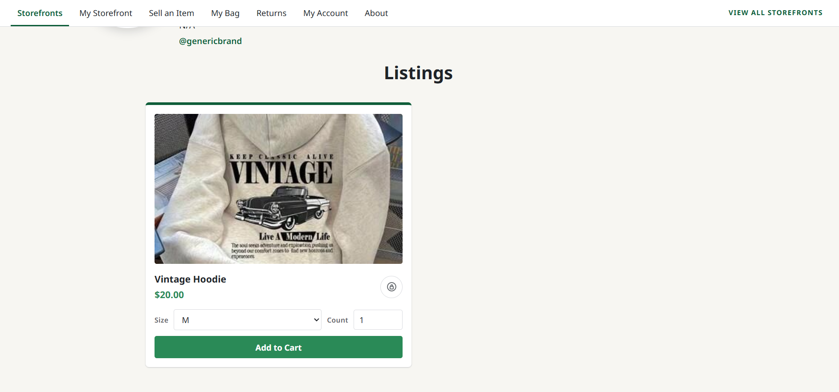  Figure 7: Listing Screen
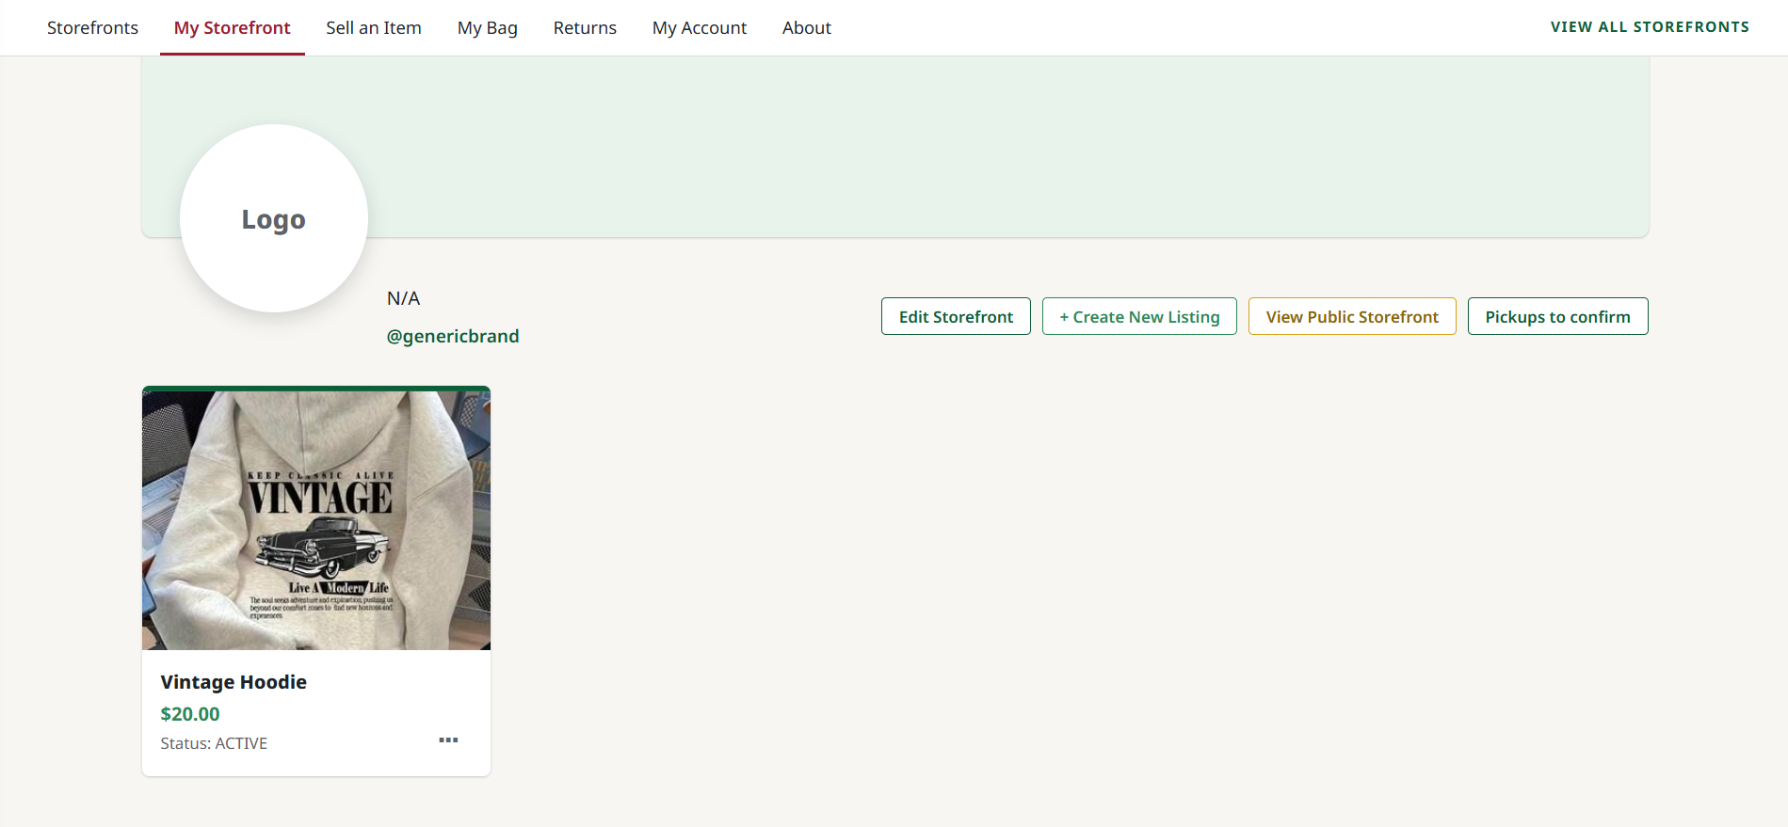  Figure 8: My Storefront Screen | 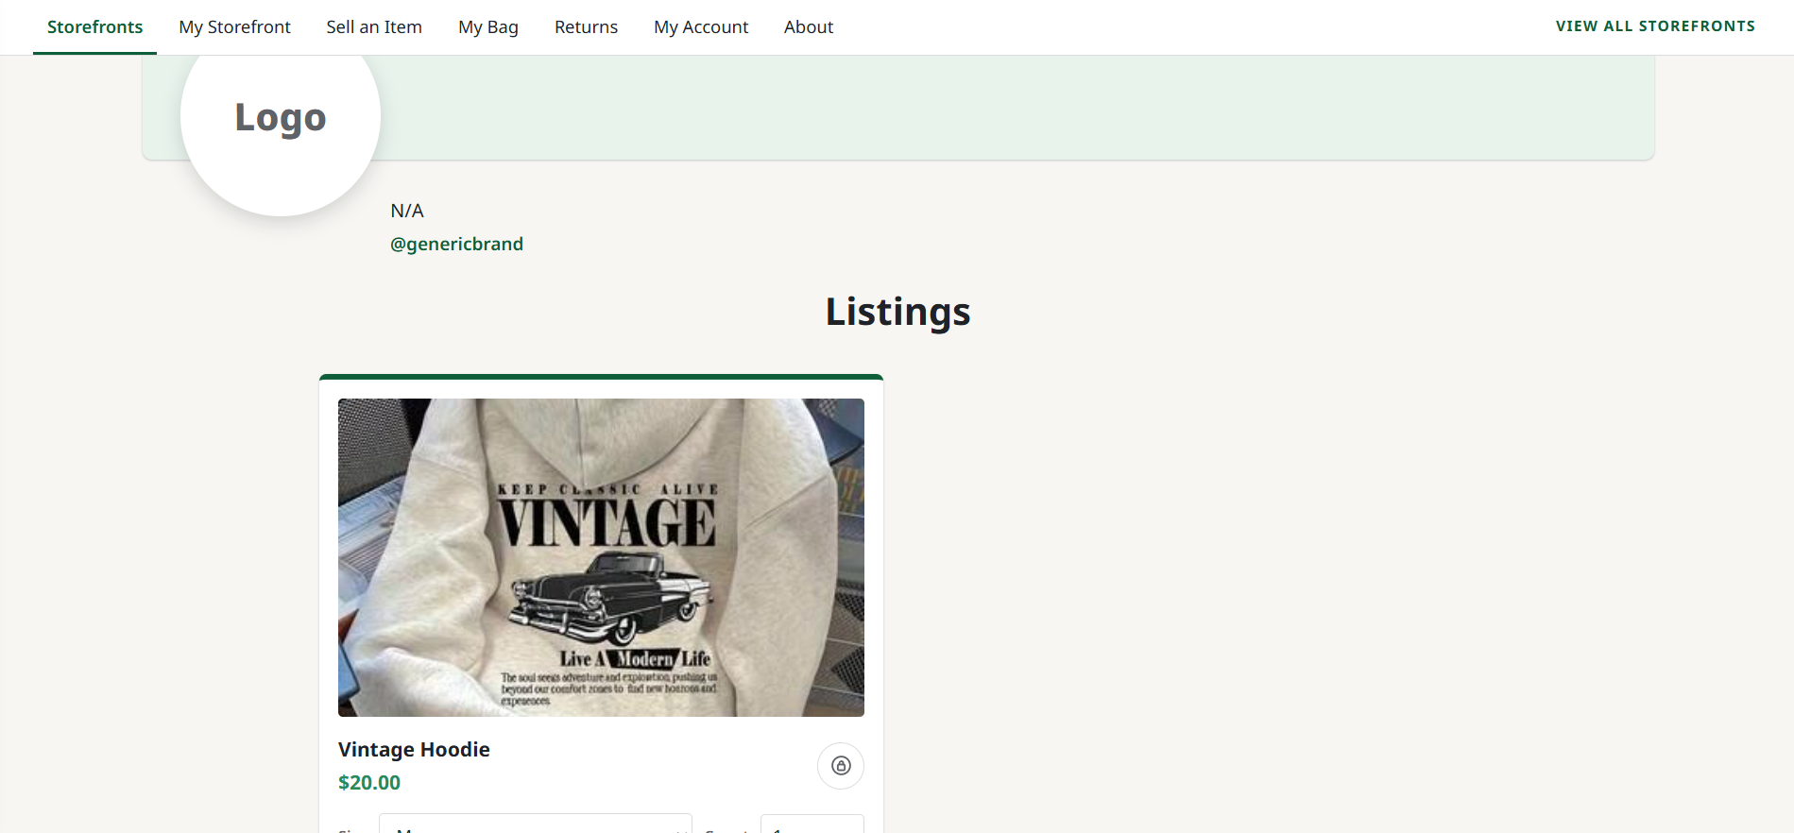  Figure 8.1: My Storefront Screen
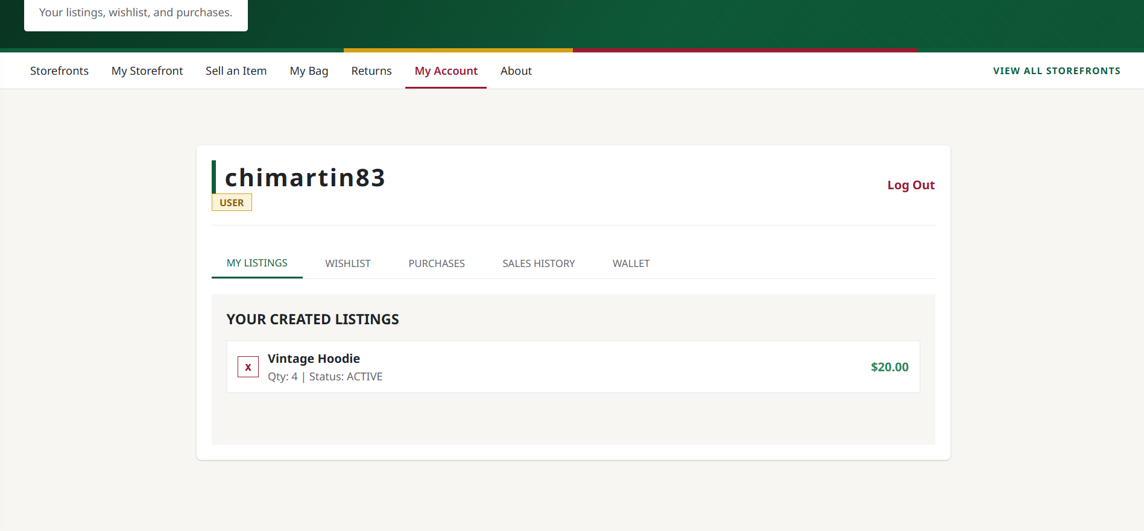  Figure 9: Account Screen (My Listings) | 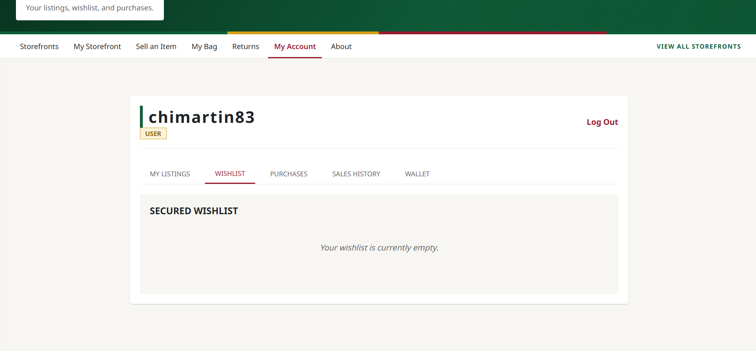  Figure 9.1: Account Screen (Wishlist)
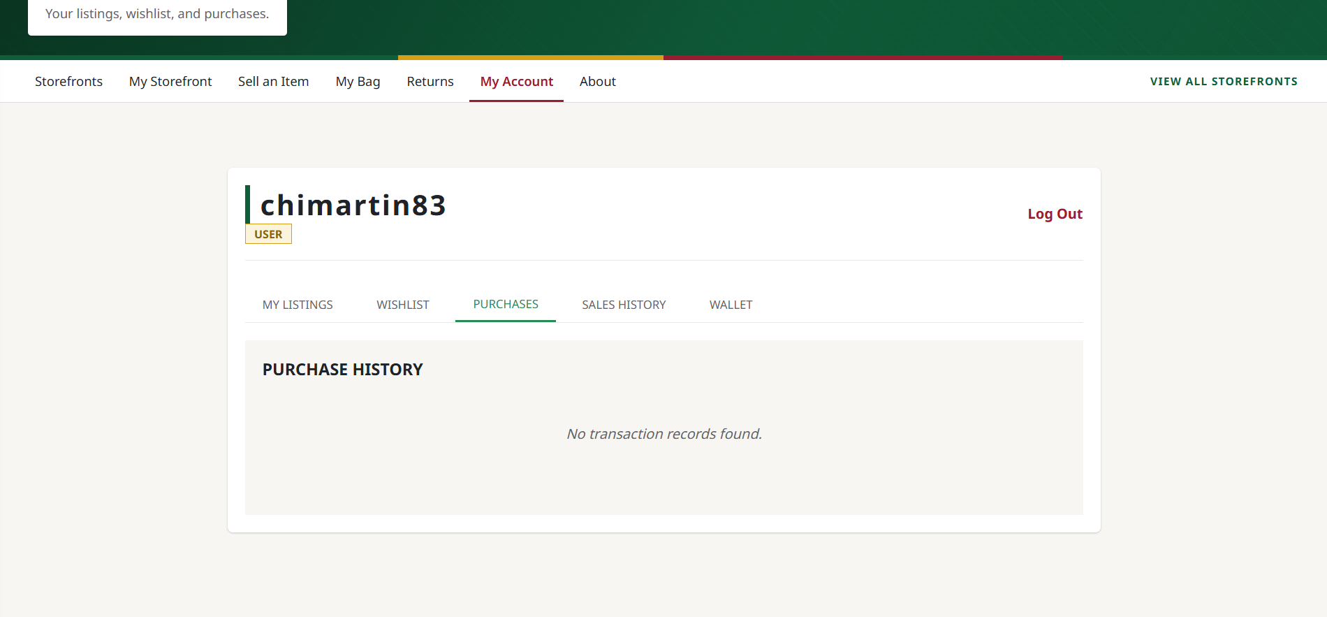  Figure 9.2: Account Screen (Purchases) | 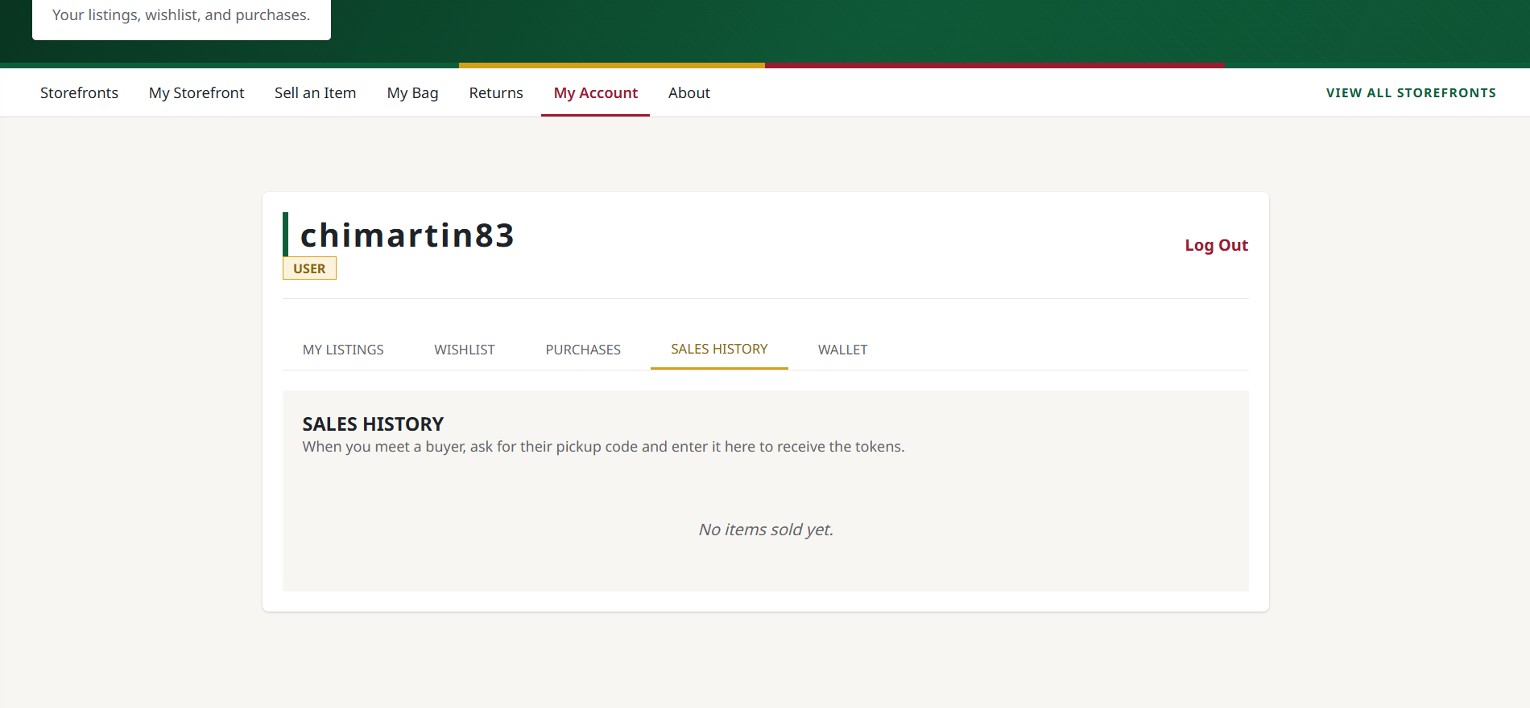  Figure 9.3: Account Screen (Sales History)
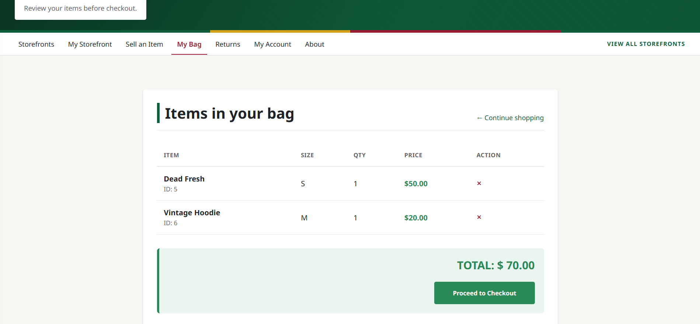  Figure 10: Cart Screen | 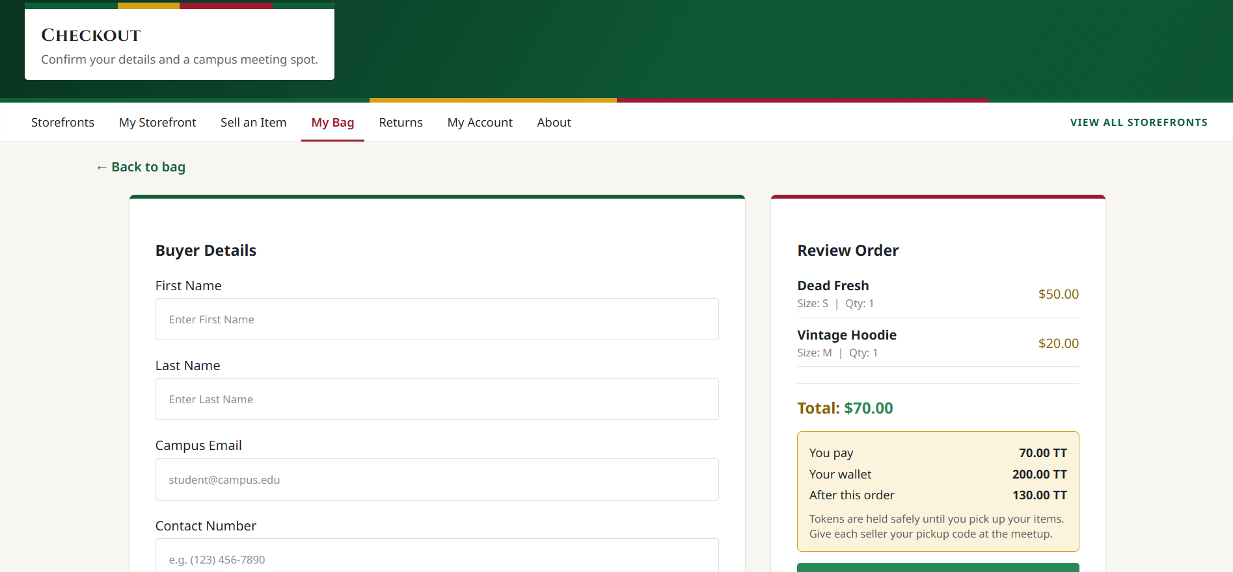  Figure 11: Checkout Screen (My Listings)
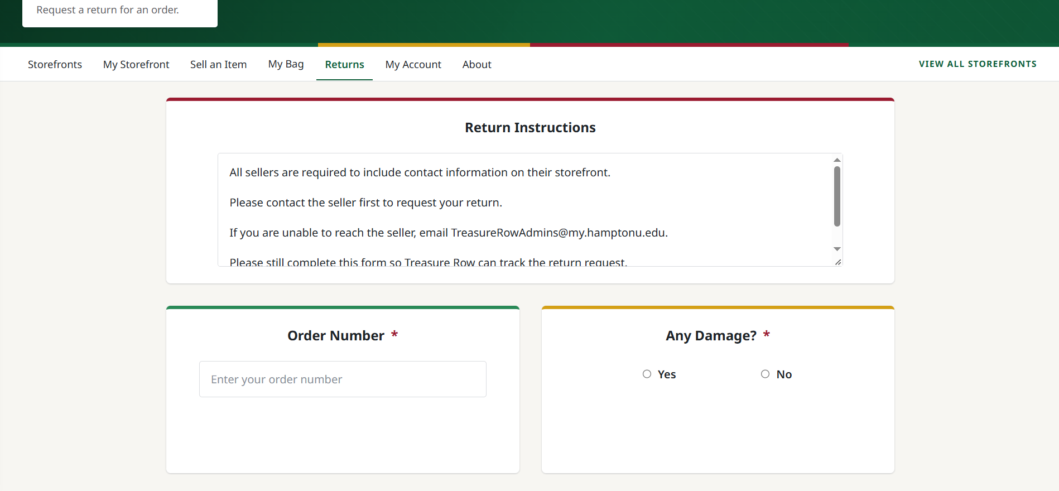  Figure 12: Returns Screen | 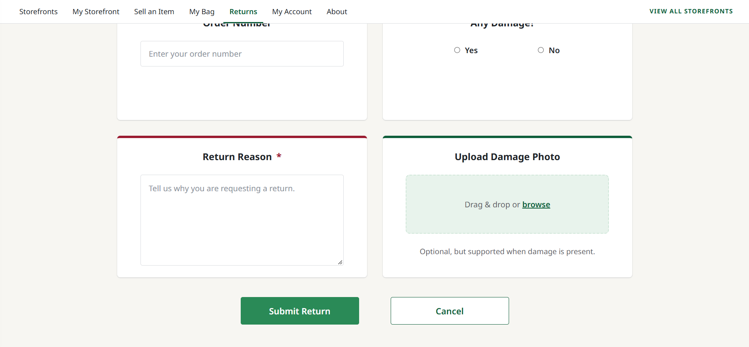  Figure 12.1: Returns Screen
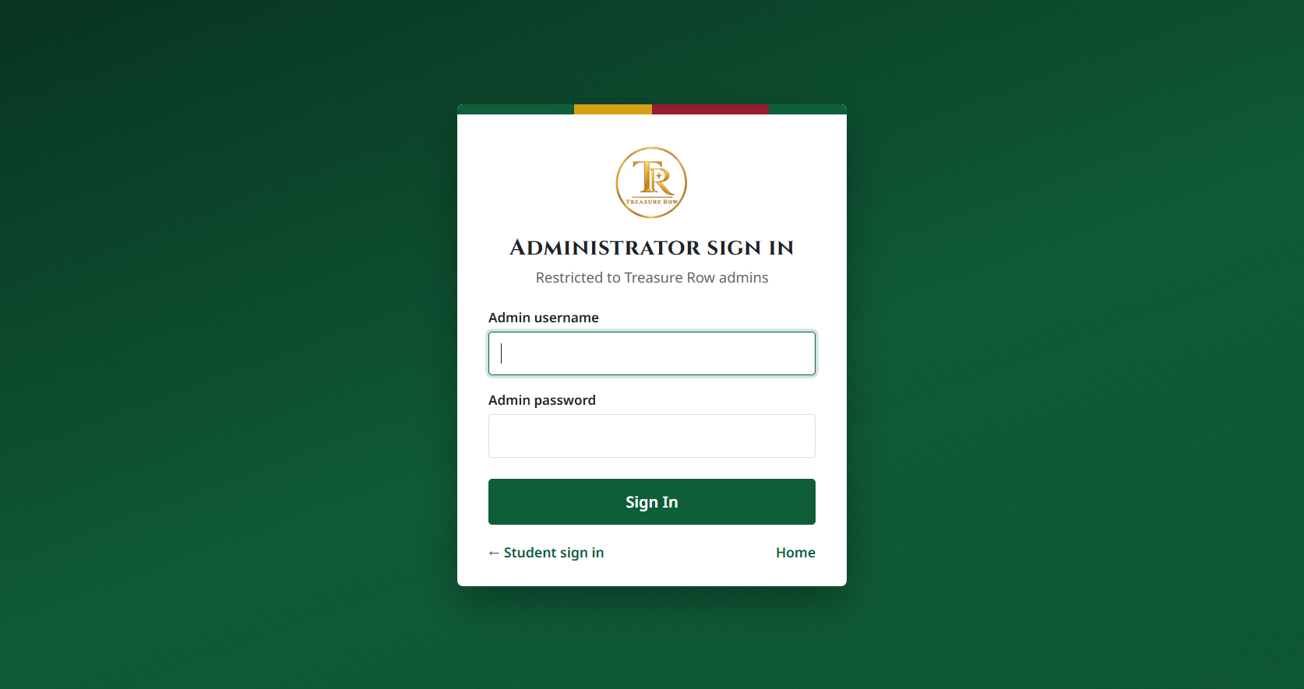  Figure 13: Admin Login Screen | 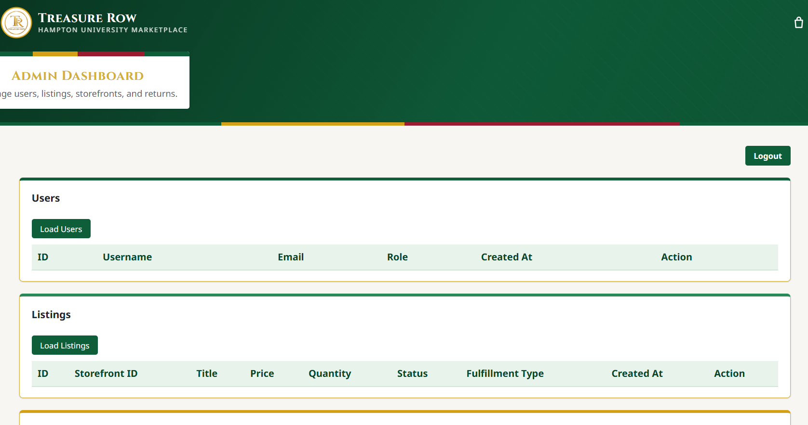  Figure 14: Admin Dashboard
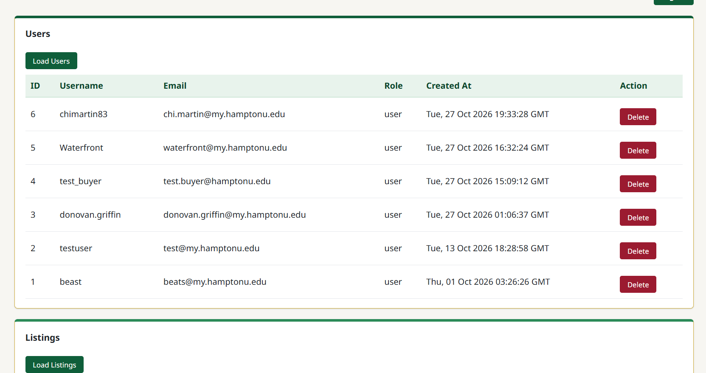  Figure 14.1: Admin Dashboard | 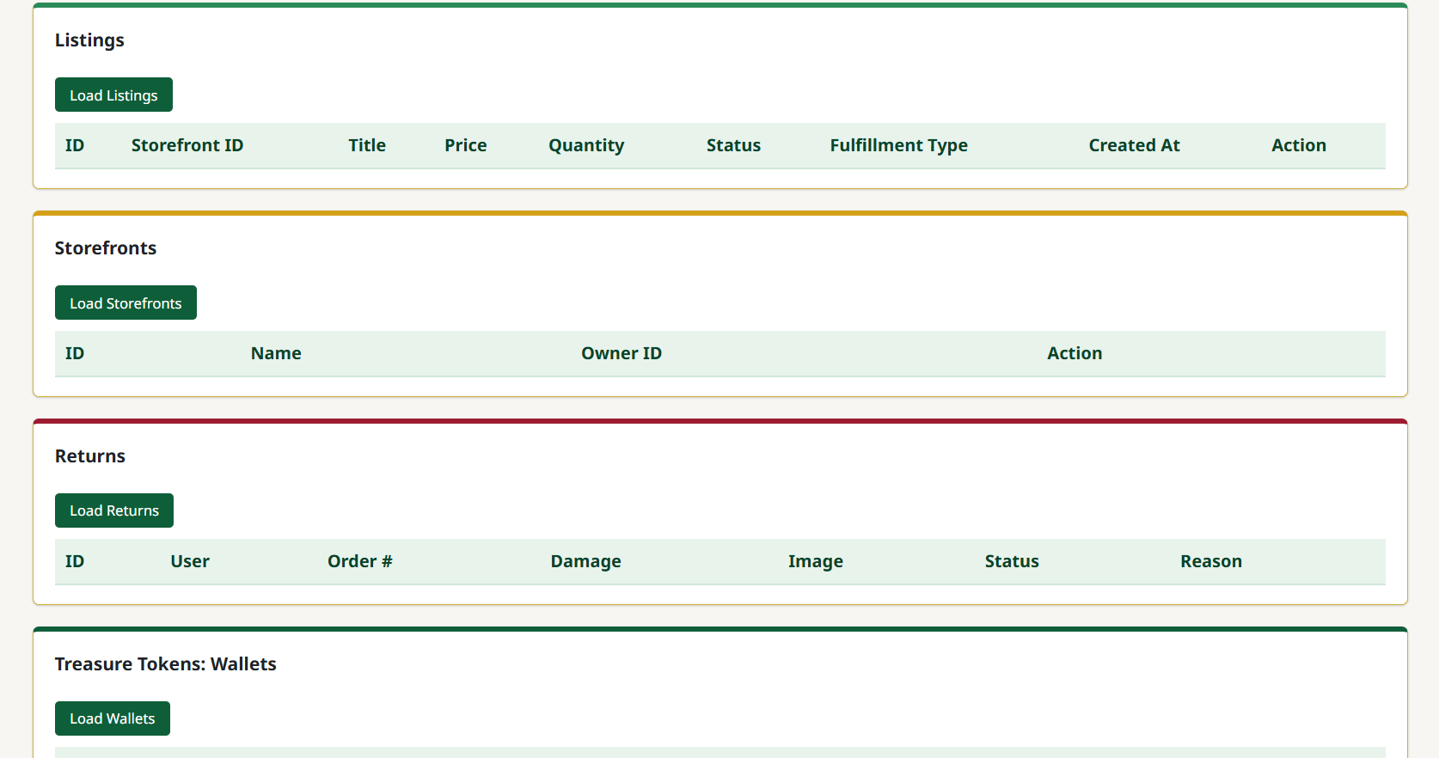  Figure 14.2: Admin Dashboard
Figure 15: Messages Screen (Jonah Goodwine): [insert screenshot of /messages showing the conversation list with an unread badge and an open conversation]

4.1.2 Objects and Actions (Chi Martin)

All screen objects and actions are identified.

Object | Action
Signup Button | Checks Hampton email criteria and runs register_user function
Login Button | Runs validate_login function
Enter Storefront Button | Routes user to individual storefront view at /storefronts/<storefront_id>
Wishlist Button | Adds listing to the user’s wishlist, displays new card on the account page (Wishlist)
Create Storefront Button | Routes user to Create Storefront page at /storefronts/create
Edit Storefront | Allows brand owners to update their brand identity by running an UPDATE command in the RDS database
Deactivate Storefront | A button that allows users to temporarily hide their shop by toggling the is_active variable in the storefronts table
Deactivate/Reactivate Listing | A control feature for individual items to manage inventory visibility by toggling the status of a listing_id to “Hidden” or “Active”
Returns Page | A screen outlining the marketplace’s refund and exchange policies
Order Confirmation Page | The post-purchase summary screen displaying item, price, date, and a unique purchase ID to the buyer
My Storefront Dashboard | A panel for sellers to view their stats and listings by running the SQL query “Select All” where the owner_id matches the current session.
Add to Bag Button | Adds selected listing to user's shopping bag
Menu Button | Opens side navigation pane
Bag Icon | Routes user to cart page
Profile Icon | Routes user to account page
Search Bar | Accepts user input to search/filter storefronts
Previous/Next Button(s) | Navigates between storefront listing pages
Upload Store Banner Image | Accepts image file input for storefront banner
Upload Store Logo | Accepts image file input for storefront logo
Brand Name Field | Accepts text input for storefront name
Instagram/Contact Info Field | Accepts text input for contact information
Store Description Field | Accepts text input for store description
Store Categories Checkboxes | Allows user to select one or more categories
Storefront Preview Images | Accepts up to 4 image files for listing previews
Create Storefront Button | Submits form, creates storefront object, displays new card on homepage
Cancel Button | Discards form and returns user to Storefront Homepage
Create Listing Button | Routes to create listing page
Storefront Name Field | Allows user to select which “user-owned” storefronts the listing will belong to
Listing Name Field | Accepts text input for listing name
Listing Image Field | Accepts at least 1 image for the listing image
Available Sizes Field | Allows the user to select up to 3 sizes that are available for the listing
Count Field | Allows text input for the amount available
Price Field | Allows text input for the cost of the listing
Create Listing Button | Submits form, creates listing object, displays new card in the account page (My Listing)
Cancel Button | Discards form and returns user to Storefront Homepage
My Listing Button | Routes to user’s listing page, displays all of the user’s created listings
Wishlist Button | Routes to user’s wishlist page, displays all of the user’s wishlisted listings
Purchases Button | Routes to the user’s purchases page; displays all of the user’s purchased listings
Sales History Button | Routes to the user’s sold history page; displays all of the user’s sold listings
Back to Storefront Button | Returns user to the Storefront Homepage
Logout Button | Logs the user out of their account and returns the user to the login page
Message Seller Link (Jonah Goodwine) | Shown on each listing to signed-in users who don't own the storefront; opens the Messages page with a conversation tied to that seller and listing
Messages Nav Link (Jonah Goodwine) | Opens the Messages page
Conversation List (Jonah Goodwine) | Shows each conversation (other user, "Re:" listing title, latest message); clicking one opens it
Unread Badge (Jonah Goodwine) | Red number showing unread messages in a conversation; clears when the conversation is opened
Send Button (Jonah Goodwine) | Sends the typed message (up to 1000 characters); errors show under the message box

4.2 Interface Design Rules (Chi Martin)
- Error feedback: The interface must present a clear, user-appropriate message when an action fails validation, authentication, authorization, or a required service operation. Messages must not expose stack traces, database credentials, secrets, or unnecessary internal details.
- Validation feedback: Invalid form fields should be identified where practical, and submitted values should be preserved when safe to do so. Client-side validation may improve usability but does not replace server-side validation.
- State consistency: The interface must not display a successful result when the underlying operation fails. After a failed checkout or token operation, the displayed order, cart, and wallet information should be consistent with the persisted state.
- Authorization: Hiding a control is not an authorization mechanism. The backend must reject unauthorized actions even if a user submits a request directly.
- Accessibility and responsiveness: Document and test the agreed requirements for keyboard operation, readable contrast, form labels, error identification, and supported viewport sizes.

4.3 Components Available (Chi Martin)
The current interface is implemented using HTML templates, CSS, and JavaScript. Jinja2 is used for server-side template rendering.
Security-sensitive interface operations rely on backend enforcement; hiding a button or restricting a page in the browser is not sufficient authorization. State-changing requests must be protected by the application's implemented CSRF controls, and the server must validate all submitted values.
Only libraries and components confirmed in the current dependency files and source code should be listed as implemented technologies. Optional or proposed libraries must be identified separately and must not be described as existing application behavior.

4.4 UIDS Description (Chi Martin)
The user interface is implemented using server-rendered HTML templates, CSS, JavaScript, and Jinja2. Flask provides the backend routes that render pages and handle form or JavaScript requests. The development team uses its chosen code editor and test tools to implement and verify the interface; these development tools are not runtime dependencies of the deployed application unless explicitly required.

5.0 Restrictions, Limitations, and Constraints (Chi Martin)

Restrictions
- Hampton University Email-Domain Restriction: Registration accepts only the email domains permitted by the application, currently hamptonu.edu and my.hamptonu.edu. This domain check is not, by itself, independent verification of a person’s current enrollment.
- Role-Based Access Control: Users are restricted based on assigned roles. Brand owners and shoppers cannot access administrative controls, and only administrators can manage all users and listings. This restriction enforces security and ownership boundaries in the system.
- AWS Resource Constraint: The application is deployed through AWS Elastic Beanstalk. Any AWS Free Tier limitation applies only to the account and services actually used; resource limits and costs must be checked against the current AWS account and configuration.

Limitations
- No real-money payment processing: Treasure Tokens are an internal application currency. The application does not process card payments, connect to a payment processor, or provide cash withdrawals.
- Manual pickup confirmation: Token release depends on the seller entering the buyer's pickup code. The system does not independently verify that an in-person exchange occurred.
- Escrow expiration: Held escrows do not expire automatically. An administrator can review and refund stale held escrows.
- Inventory restoration on cancellation: The current documented behavior refunds tokens but does not restore items to stock after cancellation.
- Deployment dependencies: Production behavior depends on the availability and configuration of the database, image storage, hosting environment, and required secrets. Local fallbacks and the automated test environment must be documented separately from production configuration.
- Scalability and performance: No quantitative capacity or response-time guarantee is established by this specification. Such bounds must be measured and documented before they are treated as acceptance requirements.
- Single-Instance Hosting (Jonah Goodwine): Elastic Beanstalk runs one t3.micro server with no load balancer. A single-instance environment cannot be paused; to save credits it is terminated and relaunched from a saved configuration, which creates a new security group that must be added to treasurerow-db-sg (see docs/aws-runbook). The live site also stops working whenever RDS is stopped.
- Messaging (Jonah Goodwine): New messages appear by checking every 10 seconds instead of instantly, and messages cannot be edited or deleted.
Constraints
- Technical Constraints: The application uses Flask, server-rendered HTML/CSS/JavaScript, and PostgreSQL. AWS Elastic Beanstalk is the confirmed application deployment platform. The exact PostgreSQL hosting service and supporting network architecture must be verified from the deployment configuration before being specified as AWS RDS or as a private VPC deployment.
- Security Constraints: Authentication, role authorization, resource ownership, input validation, and session protections must be enforced server-side. Password handling must match the actual password-hashing implementation. The system does not require or process real-money card or banking information; order contact and meeting-location details are nevertheless personal information and must be protected.
- Resource Constraints: The team must work within the AWS Free tier system. Development must also be completed within the project iteration timelines.

6.0 Testing Issues
Testing verifies that Treasure Row's implemented behavior conforms to this specification and that changes do not regress previously working functionality.
The verification strategy includes:
- Functional Testing: Verify registration, authentication, storefronts, listings, wishlist, cart, checkout, orders, returns, wallet operations, escrow release, refunds, and administrative operations.
- Authorization and Security Testing: Verify that unauthenticated users cannot access protected resources, users cannot modify another user's resources, client-supplied identity headers are ignored, and privileged operations require the appropriate role.
- Data-Integrity Testing: Verify server-side pricing, quantity and inventory validation, transactional token transfers, escrow state transitions, and wallet-to-ledger consistency.
- Input and Upload Validation: Verify rejection of invalid inputs, unsupported image contents, excessive upload sizes, and invalid storage paths.
- Regression Testing: Run the automated suite after changes affecting authentication, checkout, persistence, or authorization.
- Deployment Verification: Separately verify the configured cloud environment, database connectivity, image storage, required secrets, and end-to-end marketplace workflows.

6.1 Classes of Tests (Chi Martin)
- Security testing: Verify authentication, session handling, role-based permissions, resource ownership, CSRF protection, input validation, safe output rendering, and upload restrictions. Include tests confirming that client-supplied identity headers cannot impersonate another user.
- Functional testing: Verify registration, login, logout, storefront and listing management, search, wishlist, cart, checkout, order history, returns, administrative operations, and the implemented Treasure Tokens workflows.
- Data-integrity testing: Verify wallet debits and credits, escrow creation and state transitions, ledger entries, order totals, inventory changes, refund behavior, and rollback after failed operations. Confirm that repeated pickup-code submissions or repeated release/refund requests cannot produce duplicate transfers.
- White-box testing: Test service and model functions, validation branches, database error handling, transaction boundaries, and failure paths. Record the actual test coverage or specific functions tested rather than claiming that all functions are tested.
- Black-box testing: Execute end-to-end user workflows through the interface, including successful and unsuccessful registration, login, listing creation, cart updates, checkout, pickup confirmation, refunds, returns, and logout.
- Usability and accessibility testing: Evaluate the implemented interface against the project's agreed usability and accessibility requirements. Record observed issues and test evidence.
- Performance testing: Measure response time and resource use under a defined workload and target environment. Do not claim scalability or stress-test success without recorded measurements and test conditions.
- Deployment verification: Test the configured deployment environment separately from local automated tests, including database connectivity, image storage, required environment variables, authentication, and representative end-to-end workflows.

6.2 Expected Software Response (Chi Martin)
- Protected routes reject requests without a valid authenticated Flask session. Identity headers supplied by the client do not establish identity.
- A user cannot read or modify another user’s protected resources unless the current user has an explicitly authorized administrative role.
- The server rejects invalid listing prices, quantities, size selections, fulfillment values, or inventory changes. Checkout totals are calculated from trusted server-side listing data.
- If the buyer has insufficient Treasure Tokens or checkout validation fails, checkout does not debit the wallet or leave partial order/escrow accounting records.
- Database and image-storage failures produce an appropriate failure response; the interface does not report the operation as successful unless the required operation has completed.
- An invalid pickup code, a code submitted by an unauthorized seller, a locked escrow, or an escrow already resolved does not release funds.
- Repeated release, refund, or cancellation requests cannot create duplicate credits, refunds, or ledger movements.
- Errors are appropriate to the route and do not expose passwords, secrets, raw database credentials, stack traces, or other sensitive internal details.
- The interface reflects the persisted result of an operation and clearly distinguishes success, validation failure, authorization failure, and operational failure.

6.3 Performance Bounds (Chi Martin)

Area | Acceptance Criterion
Authentication | Unauthenticated requests to protected endpoints are rejected according to the documented route behavior.
Authorization | Requests to modify another user's protected resources are rejected, and no unauthorized state change occurs.
Checkout | Invalid prices, quantities, inventory, or insufficient token balance prevent successful checkout and do not leave partial token transfers.
Wallet | Wallet changes reconcile with the applicable ledger entries after successful operations and after failed operations.
Escrow Release | Only the authorized seller can release the matching held escrow; repeated releases and locked-code attempts are rejected
Refunds | Refunds follow the permitted escrow state transitions and cannot credit the buyer more than once for the same transaction.
Image Uploads | Unsupported image content, disallowed file types, or files exceeding configured limits are rejected without unintended storage changes.
Response Time | A numerical target is established only after defining the test environment, workload, measurement method, and percentile.
Availability | An availability target is defined only if the project has an agreed monitoring and deployment requirement.

6.4 Identification of Critical Components (Chi Martin)
The following components are critical because failures can affect security, data integrity, or core marketplace workflows:
- Authentication and session management: Establishes the authenticated identity used by protected operations.
- Authorization and ownership checks: Prevents unauthorized access to storefronts, listings, orders, returns, and administrative operations.
- Checkout and inventory processing: Ensures order totals and inventory updates are based on validated server-side data.
- Wallet, escrow, and ledger operations: Preserves token accounting, permitted state transitions, and correct rollback behavior.
- Database access and transaction handling: Maintains relational integrity and handles database failures safely.
- Image upload and storage: Validates uploads and handles storage failures without incorrectly reporting success.
- Administrative operations: Restricts sensitive actions to authorized administrators.
- Deployment configuration: Ensures the configured database, image-storage service, credentials, and application environment are available in the target environment.
Each critical component should have associated test cases and recorded pass/fail evidence. Record production deployment verification separately from local test results.

7.0 Revision Logs (Chi Martin)

Revision | By | Date | Description
1.0 | Treasure Row | 2/11/2026 | The initial document was created, and an outline and table of contents were added. Basic design layouts of the product and overview were added.
2.0 | Treasure Row | 2/12/26 | Added content to sections 1.0-6.0
3.0 | Treasure Row | 3/5/26 | Added descriptions of the user interface (section 4.1)
4.0 | Treasure Row | 3/21/26 | Added screen images of the front end in section 4.1.1, and added objects and actions for our application in section 4.1.2
5.0 | Treasure Row | 4/9/26 - 4/23/2026 | Added content to sections 2.4, 3.7.2, 4.1.2, 6.4. Updated 3.1, 3.2.2, 3.2.3, 3.3.3.5-3.3.3.6, 3.4.1-3.4.3.6, 3.5-3.5.3.6, 3.6.2-3.6.3.6, 4.1.2 to reflect the fully completed and deployed product.
6.0 | Chi Martin | October 27, 2026 | Revised the design specification for Treasure Row to reflect the current documented architecture, authentication and authorization model, Treasure Tokens wallet and escrow workflow, UI direction, limitations, and testing approach. Identified unresolved implementation details requiring verification against the current source code, database schema, and deployment configuration.
6.1 | Noah Higgs | October 27, 2026 | Added the signup username and password length rules to the registration constraint in section 4.1; every response now carries nosniff, frame, and referrer security headers; the app refuses a placeholder SECRET_KEY; order confirmation numbers use the secrets module.
7.0 | Jonah Goodwine | October 27, 2026 | Added the messages table (2.4.1 to 2.4.3), messaging endpoints and pseudocode (3.4.3.7 to 3.4.3.10), the message and authentication/cart models (3.6.3.8, 3.6.3.9), the verified AWS deployment, network access, S3 access and production URL (3.7.2, 3.7.3), messaging UI objects (4.1.1, 4.1.2), and hosting and messaging limitations (5.0).

